Dr.Eswaran A
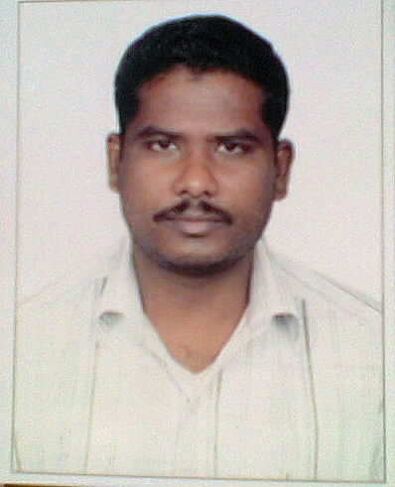

Junior Resource Person-Tamil (Academic)
National Testing Service-India
Central Institute of Indian Languages
Mysore, Karnataka -570006
Mobile: 9013942343(KA), 9487581815(TN)
Email: aeswar94@gmail.com
------------------------------------------------------------------------------------------------
Date of Birth : 03-02-1988
Sex : Male
Nationality : Indian
Qualifications : PhD in Tamil with JRF (JNU, New Delhi.)
Research Interests:
Translation, Cultural Studies, Classical Tamil Literature.

Known languages

Tamil (Mother tongue), English, Telugu, Kannada, Hindi (speak and understand)

Other interests
- In my college days I have published one poem book MANJAL POOKKAl(Yellow flowers)
- I have translated other language poems into Tamil
- I am translating sangam literature (kurunthogai) into Telugu with my own interests (not yet publish)
- Recently I have published my own novel MAHISHASURAN.( Own publication ISBN No: 978-93-5311-885-3)
- Some translated poems and shot story have published in magazines.
Skills
- Basic computer applications like MS word excel etc...
Award/honour
- School 2ND position in 10th on 2004.(423/500)
- 1st position in M.A on 2011(79.9%)
- Payanam Literary magazine award for Novel in Dec16, 2018.
Habits
Reading and writing novels and poems.
Translating poems from other languages to Tamil.

Academic Qualifications:

Year | Class/ Degree | Name of the Institution | Discipline/Subjects | Percentage/  Grade
2003-04 | 10th | Govt (A.D.W) Hr.Sec.School, Mattukkaranur,Salem, TN. | Maths, and Science,  Social Science. | 85%
2004-06 | +2 | VC Higher Secondary School  Omalur, Salem, TN. | Bio-Maths | 72%
2006-09 | UG | Thiruvalluvar Government Arts College, Rasipuram, Namakkal, TN. | Tamil, Translation theories, | 53%
2009-11 | MA | Dravidian University, kuppam, AP. | Tamil, Telugu, Translation theories, | 80%
2011-13 | MPhil | Jawaharlal Nehru university,  New Delhi Delhi. | Research Methodology, bibliography Research | 7 CGPA
2013-17 | PhD | Jawaharlal Nehru university,  New Delhi Delhi. | Cultural studies (Popular fiction) | Awarded on 2nd may 2018

Fellowship/Awards:

- Qualified under National Eligibility Test (NET) conducted by University Grants Commission, India.

- Awarded Junior Research Fellowship (JRF) in Tamil by Ministry of Human Resource Development, Government of India.

Paper presented in seminar and conferences:
- January-2013: Tamil literary development though translation (From Telugu to Tamil) presented at the national Conference on Current trends in the development of Dravidian language, conducted by school of Indian language of Tamil University, Thanjavur . (on January- 10, 2013)
- April-2013: A study of Tamil classical literature in Telugu Translation presented at the National Seminar on Classical Tamil Literature in the Context of Indian Literary Tradition organized by School of Language, Literature & Culture Studies, Jawaharlal Nehru University, New Delhi. (from April 3rd to 5th 2013)
- December-2013: Tarrchirappu payirangal vazhi ariyalagum ilakkana thevaiyum nookkamum presented at the National Seminar on Tamzhayvuk Kalngal Organized by Tamil department of presidency college, Chennai. (0n December 18,19,20th 2013)
- March-2017: kurunthogai’s Telugu translation: try and ideas, presented at the National Seminar on Ancient Tamil culture through multiple perspective, organized by School of Language, Literature & Culture Studies, Jawaharlal Nehru University, New Delhi. (from march 17th to 18th 2017)
- March-2019, Classical features of a love Remorse’s Tamil folk song at International Conference on Folklore and Philosophy, And Other Issues in Thunchath Ezhuthachan Malayalam University, Malappuram, Kerala. (from march 15th to 17th 2019)

Published Article
- July-2013: Critical bibliography of Translation published by Sitredu (quarterly Tamil journal)issue: July-September, ISSN No:2249-1961
- July 2016:thennithiya kelikkaip punaivu mozhipeyarppukal published by modern thamizh research (A quarterly international multilateral Thamzh journal)issue: July-September, ISSN No:2321-984X
- June-2017:Telungu kelikkaip puthinangalukkana inaiyavali Ethirvinaikal published by thisaiyettum (A quarterly Translation Thamzh journal)issue: april-june, ISSN No:0976-3767
- November-2017:vangala thiraippalalin chevviyal thanmai published by Inam(An Internationally Refereed e_ Journal of Tamil Studies) issue: November 2017 Volume III Issue-11, ISSN : 2455 – 0531
- Auguest-2018 Tantric songs in Eastern India published by Inam(An Internationally Refereed e_ Journal of Tamil Studies) issue: Auguest-2018, Volume IV, Issue-14, ISSN : 2455 – 0531
- February-2019, serious theme through popular story telling: Thamilavanin’s Adipaavai poola published by Inam(An Internationally Refereed e_ Journal of Tamil Studies) issue: Auguest-2019, Volume V, Issue-16, ISSN : 2455 – 0531
About to publish (2019)
- The place of popular fiction in teaching literature: NTS-I perspective in Malaysian Journal of Social Sciences and Humanities (MJSSH) ISSN:2504-8562
- Translated research article from English to Tamil about 21 century Bengali poetry with author permission Form Sahitya Akademi literary magazine Indian Literature 2017, March/April.

I hereby declare that the above mentioned information is true and correct to the best of my knowledge.

(A.Eswaran)

