CURRICULUM VITAE

Elena Logosha 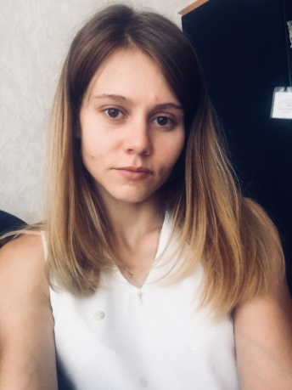

Personal information

Address: Sovetskaya Str. 51, 309650, Belgorod region, Russia

Telephone: mobile: +79511506270 (WhatsApp)

Email: elenalogosha25@gmail.com

Date of birth: 11th June 1993

Nationality: Russian

Marital status: married

Objective: position of interpreter

Education

Belgorod State University (BSU), Institute of Intercultural communication and International Relations. Specialist’s degree in translation and interpretation studies (2011-2016).

Work experience

Freelance, October 2017-present

Belgorod, Russia

Work as a translator

“Visa 31”, June 2016-August 2017

Belgorod, Russia

Worked as a translator and visa manager

- Translation of the documentation (eng-rus, rus-eng).
- Documents preparation
- Visa assistance
- Advising clients

Personal qualities

- Articulate
- Determined
- Diligent
- Highly trainable
- Fast learner
- Responsible
- Patient

Special skills
- Native Russian
- Fluent English
- Working knowledge of German (basic knowledge)
- PC, MS Office, advanced user PC and Internet
- Driving License (Category B)

Hobbies
Reading books, listening music, foreign languages, traveling.

