Eddyne YAMUREMYE, M.Sc.  Professional Translator/interpreter  Profile  Degree-level education and six years of experience in translating and other consultancies. Highly literate with a keen eye for detail. Various training and contacts have improved my capacity to interpret and communicate data fast and correctly, no matter how irregular it is. Excellent planning and marketing abilities. Experience in both private and public sectors. A natural leader and team builder who thrives in a fast-paced business environment.  I also get along well with folks from different cultures and enjoy learning from others. |  |  | 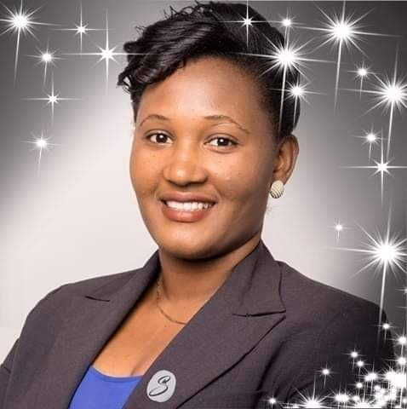
Contact  NTAHANGWA Commune  Buterere, Miroir Cell  Bujumbura, Burundi  (+257) 79 312 934  61 61 62 63  yan.eddyn@gmail.com  LANGUAGES  - KIRUNDI: Native  - FRENCH: Proficient  - SWAHILI: Proficient  - ENGLISH: Proficient  Hobbies  Music  cinema  travel |  | EDUCATION  Jomo Kenyatta University of Agriculture and Technology – Nairobi,  Kenya  2016 - 2018  Master of Science in Mass Communication (Corporate  Communication) |  Light University of Bujumbura (Université Lumière de Bujumbura)  2009 - 2013  Bachelor’s degree in communication sciences: Development  option  WORK EXPERIENCE  LIGHT UNIVERSITY OF BUJUMBURA, Communication full Time lecturer  March 2016 – Present | Bujumbura, Burundi  My responsibility includes providing knowledge for the following.  courses:  - Public Relations,  - Social Change,  - Marketing & Communication, and  - Corporate Communication Practice  - etc.  SECRETARY GENERAL at EAST AFRICA COMMUNICATION ASSOCIATION (EACA)  INTERNATIONAL UNIVERSITY OF EQUATOR, January 2019 – August  2021 | Bujumbura, Burundi  A full-time Lecturer, teaching a minimum of nine units/ year in both I.T &  B.A departments. Those courses cover both Management and  marketing domains. They include:  - Channel management,  - Principles of Management,  - International Business Management,  - Introduction to development studies,  - Human Resource Management,  - etc  HEALTH POVERTY ACTION (HPA), Communication Officer,  April 2017 –May 2017 | Rwanda  AFROCOM, Communication Manager,  March 2014 – April 2015 |Burundi  Excellent interpreter (both simultaneous and consecutive) in 4 languages (French, English, Swahili, Kirundi)  - Conférence International des femmes leaders au Burundi : 1ère, 2-ème et 3 -ème édition 2018, 2019, et 2020  - Ateliers sur la construction du chemin de fer UVINZA MUSONGATI GITEGA, RDC-Uvira 2018, Bujumbura 2019, etc.  - 58eme Caucus africain sur les finances, Bujumbura, Août 2021  - Réunion de négociations sur le partenariat entre le Burundi et le Nigeria, Bujumbura, 2021  - Etats généraux sur l’éducation, Burundi 2022  - Journée sur l’accès à l’énergie au Burundi, octobre 2022  - Etc.  SKILLS  Excellent use of the Internet as a medium of communication and research tool.  - Proficiency in using Microsoft Office tools such as Word, Excel, PowerPoint, Outlook.  -Conference organizer (EACA Conference Convener of 2022)  TRAINING AND SEMINARS  2021-2022 Formation sur le facts checking, les médias par PAPROM/ Université de Lille, France  November 2018 ^{Online} Young African Leaders Initiatives Network Achieved 16 certificates of completion for online courses: “Understanding women and girls’ rights”, “Fundraising of grants writing”, etc.  March 2016 – February 2017 Kigali - Rwanda Potter’s Hand Leadership Center, Certificate of Completion I was trained in Visionary Leadership. I achieved a certificate of Excellence in addition to the certificate of completion  September 2013 Bujumbura - Burundi Burundi Investment Promotion Authority, Certificate of Attendance Training in Business Plan Writing  August 2013 Bujumbura - Burundi COMESA – Regional Investment Agency, Certificate of Attendance Training on Foreign Direct Investments trends, competitiveness, technics and functions in investment promotion.  STUDIES AND RESEARCH  Research paper  “Influence of Integrated Marketing Communications Tools on  Adoption of Telecommunication Innovations.”  (Published in IJSR)  - Bachelor’s degree research paper  “Le Branding du Burundi à travers le Tourisme” presented and  published in April 2015 with a score of 15.5 out of 20.  https://www.academia.edu/24166291/Le_Branding_du_Burundi  _a_travers_le_Tourisme  REFERENCES  - Bruce BERAHINO, CEO at Great success Company, bruceberahino@gmail.com  - Domitien NDIKUMANA, CEO at Concise Business Group info@concisebusinessgroup.com  - Armel ISHIMWE, Doyen de Faculté Sciences de la communication ishimwearmel@gmail.com  I certify that the information given above is accurate to my knowledge.  Bujumbura, Thursday, February 29, 2024  Eddyne YAMUREMYE, M.Sc.

