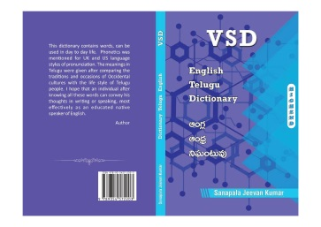
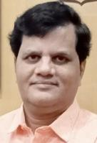
S. Jeevan Kumar Lexicographer
sajeku@gmail.com; WhatsApp +918247829025
Career Objective:
To meet the unprecedented tasks in order to reach the predetermined deadlines with optimum efficiency for the mutual growth of organization and myself.
Qualification:
* Diploma in Journalism
* Diploma in IPA.
Experience:
Soft Skills training using Ishikawa, Out of Box and Monkey in the Cage concepts
Spoken English training with syllable division, syllable stress, reductions and connected speech
Drafting betterment training with persuasiveness skills
Making videos in connection with pronunciation and word power
Providing Content for various portals and magazines on freelance basis
Translating the content on both online and offline platforms in English –Telugu language pair
Prestigious Projects:
Application of soft skills among teachers for better interaction with students
Improving reading skills among school students within a week
Drafting improvement for central government employees
Online - Google NMT Translation
Offline - Sony Brochure Translation
Extracurricular activities:
* Published VSD English – Telugu’ dictionary for high - end people, compiling the words used in mass communication with 3500 head words, 55000 Telugu Words and 3.2 Lakh characters, which is first of its kind while giving IPA for UK & US styles of pronunciation with ISBN 9789354572203.
* You Tube video link https://www.youtube.com/watch?v=92Ez8_YFetA&t=34s
* Compiled Glossary for Polytechnic English Text Book “INTERACT” – C 20
Strength:
Ability to do analyze the situation from the end user’s view.
D. No 39-22-82/1; Kalinga Nagar; Visakhapatnam; Andhra Pradesh; India ; PIN 530007

