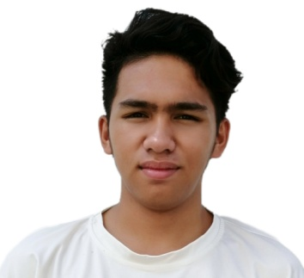

AREAS OF EXPERTISE

Translating Medical documents

E-learning

Press release

Technology

PERSONAL SKILLS

Detail orientated Well-organized Friendly

PERSONAL DETAILS

Brgy. Kapatagan, Digos City, Davao Del Sur, 8002

M:+639122663443
E:shinichi051600@gmail.com

DOB:16/05/2000
Nationality:Filipino
Dharelle P. Giger

Translator – English To Japanese To Tagalog

PERSONAL SUMMARY

A multi-skilled, reliable and talented translator with a proven ability to translate written documents from a source language to a target language. A quick learner who can absorb new ideas and can communicate clearly and effectively with people from all social and professional backgrounds. Well mannered, articulate and fully aware of diversity and multicultural issues. Flexible in the ability to adapt to challenges when they arise and at the same time remaining aware of professional roles and boundaries.
Would like to work as a translator for a successful and ambitious company that offers great opportunities for career development and progression.

WORK EXPERIENCE

Freelance
TRANSLATOR June2018 - Present

Working freelance for a translation agency providing a translation service to clients where needed. Involved converting documents and articles from one language into another and ensuring that the finished converted articles relay the intended message as clearly as possible.

Duties:
Researching legal and technical phraseology to ensure the correct translation is used. Liaising with clients to discuss any unclear points.
Providing guidance and feedback and creating customer-specific style guides.
Working as a translator for charities and local councils. Supporting the translation team with other projects when necessary.
Retrieving articles from newspapers, magazines and the internet and translating them into English.
KEYSKILLS AND COMPETENCIES Familiar with translation software tools.
Excellent communication and social skills. Able to work to tight deadlines.
Highly skilled in Word, Excel and Microsoft Outlook.
Able to prioritize work.
N3 Level of Japanese proficiency.
I lived in Japan for 5 years.

ACADEMIC QUALIFICATIONS

Currently taking Bachelor of Science in Secondary Education Major in English.

REFERENCES–Available on request

