CURRICULUM VITAE

Personal Information
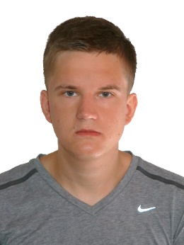

Name: Denis
Surname: Kasper
Birth Date: 1992-05-23
Birth place: Vilnius, Lithuania
Mobile phone number: +447503122132
E-mail: deniskasper777@gmail.com

Education

2011 - 2015 Vilnius Business College, Applied English Language, BA
2003 - 2011 Vilnius Antakalnis secondary school
1999 - 2003 Vilnius Volunge primary school

Work Experience

2016 september – Mercure Holland House hotel, Waiter
2015 november – 2016 july – Roadchef Ltd. McDonalds Crew Member
2014 august - 2015 may - JSC “Girteka Logistics“ preparation of road freight goods for transportation
2014 april - may - JSC "Palink" "IKI" shopping centre, Selių str. 54,Žvėrynas, shop assistant
2013 June -October - Aldemar Paradise Mare hotel,Rhodes Island,Greece, assistant waiter trainee
2012 December - International Christmas Charity Bazaar

Language skills:

Languages:
Lithuanian - fluent speaker (C2)
Russian- native(C2)
English - fluent speaker(C1)
German- beginner(B1)

Computer skills:

Programmes:
MS Word - advanced user
MS PowerPoint - advanced user
Internet Explorer - advanced user

Personal characteristics:

Honesty, discipline, serious attitude to work, no unhealthy habits

Motivational letter

My name is Denis Kasper and I am writing to apply for a job position in your company. I think that I am suitable for this position because I believe that I can help the company to deal with its everyday business operations and thus make a significant contribution to a company's success. Also, I can gain a lot of priceless experience which will be extremely useful in my future career.I think, that I have enough competence and knowledge in order to perform properly.I am able to concentrate on the most important business tasks, also I learn from my mistakes. Therefore, I hope ,that while working in Your company, I will improve my skills and explore new areas.

