**Débora Ferraz do Amaral**

Phone number: +5531 993652336

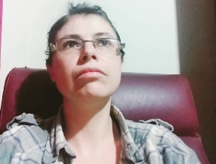Address:Ramalhete Street nº88 apt 202. City: Belo Horizonte.

Zip Code:30310-310 Brazil.

I have a large experience with translation and interpretation for over ten years . I'm looking to grow in the area to bring excellence to translation .

**Skills:**

Social media,I.T, journalism, teaching languages, simultaneous interpretation, hearing, translation of documents, books ,essays , articles,scientific articles,Psychology,Law general,Medical general,Medical Health, Goverment,Politcs, Multimídia,Cinema ,film,TV drama,Subtitles,Psychology.

**Languages:** **Languages: Written, heard,spoken**

Brazilian Portuguese: Fluent Native

English:

Fluent

Spanish:

Advanced.

French:

Intermediate .

**Target Languages:**

English Brazilian Portuguese.

Brazilian Portuguese English.

English - Spanish

**Labor prior experiences:**

Helpassessory translator ,interpreter and private teacher of Portuguese and English ,English Portuguese , in Brazil , São Paulo, Minas Gerais, Brazil.

Jun 2009 until 2020..

Freelance translator and interpreter in Dublin Ireland of Portugue and Spanish to English.

Jan 2013 to June 2013.

Unattended translator with company tradutorium, Sergipe, Brazil.

Nov 2012 to Sep 2013

Professor of Portuguese and English language in

State School Luiz Simione Sobrinho, São Paulo, Brazil.

May 2009 to Sep 2009.

**Education:**

UNIP Graduation (2008/2010)

Psychology Graduation (2018/2022)