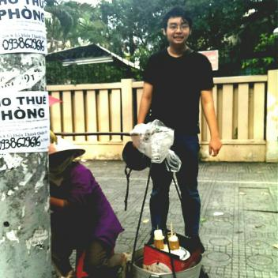  Contact Information  126 Than Nhan Trung, W13, Tan Binh Dis  01203157296  congtuyeunhac9x@gmail.com  Achievements  Documents I translated:  - OCB Bank: Credit contract  - Kien Phat’s Process of Inheriting and developing traditional ceramics in Binh Duong province  - Ancient Spirit (wine company) report  - Dai Phat Minh Sewing Co., Ltd Internship report  - An Binh Packaging Printing Co., Ltd Financial report  - University Degree: MEIHO  - Letter of justice curriculum vitae  - Certificate of marriage  - Investment contract  - Decision of Police station  - Financial Statement Singapore Illustrative  - Technique documents: Merge pump  - Film sub/dub: Now you see me 2, Finding Nemo 2  - Advertisement: New beginning, Death disaster of VN Centre  ….…. | BUI LUU THANH DAT  TRANSLATOR  Summary  I’m a simple man, I used to work in many sectors and companies. Each time I quit job, each time I get more and more experiences. My best character is responsibility, therefore, every mates in team always believe to give me professionals. I just never make anyone disappointed.  Work Experience  Server/Cashier/Chef 2013 – 2014  Pizzahut  Carl Jr  Texas Chicken  Popeyes  Mc Donald  …...  Sale man 2014 – 2015  Megastar (CGV now)  Translator/Interpreter 2016  Interprotrans company  COMMUNICATION  ORGANIZATION  TEAM PLAYER  CREATIVITY  SOCIAL  Skills  SPEAKING  TRANSLATION  READING  LISTENING  INTERPRETATION  PERSONAL  Education  Bachelor of Translation University of Technology Foreign Trade Business Administration

