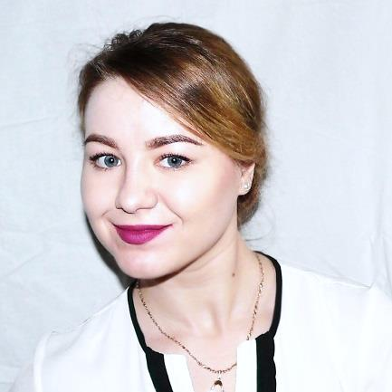**EDUCATION**

**🖂 darya.kolganova1@gmail.com**

**✆ +77071421196 (WhatsApp)**

**BIRTH DATE -** 11.12.1994

**NATIONALITY** - Kazakhstan

**LANGUAGES**

**Russian:** Native

**English:** Fluent

**Spanish:** Conversational

**CERTIFICATES**

**Legal Translation Basics (English –Russian)** by *Caspian Training Group* (November, 2019)

**Crowd Management Certificate** bythe *Maritime Bahamas Authority* (expires in April, 2022)

**Security Awareness for Cruise Ship Staff** by *Marlins* (November, 2016)

**Food & Beverage Professional** by *Hideaway Beach Resort and SPA*

**EFR-Primary Care (CPR) & Secondary Care (1st aid)** by *PADI*

**PADI Divemaster/ Freediver + Fish ID/ Enriched Air Diver/ Digital Underwater Photographer**

**Al-Farabi Kazakh National University**, Almaty, Kazakhstan

**Bachelor of Tourism Studies** **│**2012 - 2016

**Janos Kodolanyi University of Applied Science,** Budapest, Hungary **International Academic Mobility Program Student**│2015 - 2016

**Educational language center “ABC”,** Temirtau, Kazakhstan

**English language translator│2009 – 2012**

**WORK EXPERIENCE**

**Freelance Legal Translator│Bureau of medical translation MedConsult**

**DARYA**

**KOLGANOVA**

**TRANSLATOR**

*September 2019 to Present*

* Translation of legal documents from English to Russian ensuring accurate translation using proper legal terminology
* Knowledge in MemoQ CAT software

**English language teacher│Educational language center “CHELS”**

*Almaty, Kazakhstan│2013 - 2014*

* Teaching general English Elementary to Upper-Intermediate levels) to individuals and small groups of up to six students (adults and kids 6+ y.o.)
* Maintaining classroom and student records in accordance with school policy
* Lesson planning and designing short courses

**ADDITIONAL BILINGUAL WORK EXPERIENCE**

**Restaurant waitress │Palazzo Versace Hotel Dubai**

*Dubai, UAE │February 2020 – December 2020*

● Taking accurate food and drink orders using a POS system ● Responding to guest requests in a timely, friendly and efficient manner while ensuring a positive guest experience ● Deliver checks and process payments

**PADI Divemaster Internship│** **Dressel Divers Bavaro**

*Bavaro, Dominican Republic****│*** *April 2019 – August 2019*

● Assisting with courses in confined and open water, assisting with dive logistics ● Guiding snorkelers and certified scuba divers dives ● Striving to maximize guests’ satisfaction with services we offer

**Restaurant waitress │Hideaway Beach Resort and Spa**

*Republic of Maldives* ***│****December 2017 - December 2018*

● Greeting and escorting guests, presenting menu, answering questions, providing the perfect food service experience while applying positive suggestive sales approach to guide guests, using up-selling techniques when appropriate ● *“Employee of the month”, “Best Smile of October”*

**Fine dining restaurant waitress│Silversea Cruises Ltd.**

*“Silver Wind” vessel, worldwide***│***January 2017 – July 2017*

● Learning the standards by meeting the relevant restaurant company standard procedures ● Learning the regulations and procedures of the USPH and adhere to these standards, at all times ● Serving passengers to the highest standards set by the company ● Attending various training session with the aim to further improve level of performance

**Restaurant supervisor (waitress: 2015 – 2016)│“Preussen” restaurant**

*Almaty, Kazakhstan****│****October 2016 – January 2017*

● Resolving customer complaints regarding food service ● Assigning duties, responsibilities, and workstations to team members in accordance with work requirements, providing employee orientation and training, observing and evaluating work procedures to ensure quality standards and service

**REFERENCES**

*Chloé von Känel*, Dive Boss, Dressel Divers Bavaro, chloevonkaenel@gmail.com

*Shankershan Ghosh*, Assistant F&B manager, Hideaway Beach Resort and SPA, +9607895868

*Yermek Jumanov*, Restaurant Manager, Preussen restaurant, +77011200120

*Artemyev Alexander*, Head of Department of Recreational Geography and Tourism, al-Farabi KazNU, +77772490272