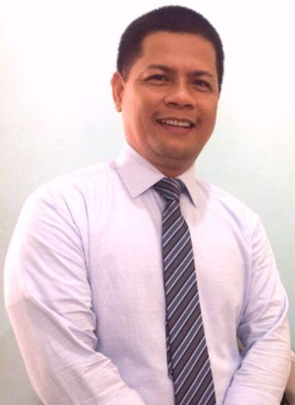
Resume of DANILO AVILAR ABRIGO
Desired Position: Language Translator (English to Cebuano)

Personal Data
Name: Danilo Avilar Abrigo
Address: D2, Aranas Bldg., J. Rodriguez Ave. cor. Gem, Maa
Davao City, Philippines
Mobile: +63 923 388 0091
E-mail: abrigodann@gmail.com

CREDENTIALS
Diploma in Human Resource Management
Institution: Advance Learning Interactive Systems ONline (ALISON)
Completed: 2014.05.20 | Country: Ireland

Certificate in English Vocabulary and Pronunciation
Institution: Advance Learning Interactive Systems ONline (ALISON)
Completed: 2014.05.20 | Country: Ireland

Basic TESOL Certificate Course
Institution: The School of TEFL–Udemy Online
Completed: 2014.06.06 | State: California

Bachelor of Science in Commerce, Major in Management
Institution: San Agustin Institute of Technology
Completed: 1995.03.24 | Country: Philippines

WorkS / Experiences
Translated 20 Christian Books (English to Cebuano) of the New Life Mission in South Korea. The e-books are now available at http://www.bjnewlife.org/english/ebook/ebook_edition.php?bid=447.

Compiled and Published An English-Tagalog-Cebuano Dictionary. A copy of it is deposited at the National Library. http://koha.nlp.gov.ph/cgi-bin/koha/opac-ISBDdetail.pl?bib=280689.

Authored a book “When Wife Betrays….” Now available at Amazon.com.
https://www.amazon.com/When-Wife-Betrays-Danny-Abrigo-ebook/dp/B00E7NC4PK.

Branch Head
Firm: Mindanao Daily News - Davao Regional Office
Period: June 2017 to present

Self-employed Business
Firm: Davao Technoprint in Davao City
Period: 2002 - Present

Classroom Teacher (Computer Subjects)
Institution: San Agustin Institute of Technology in Valencia City, Bukidnon
Period: 1992 - 1995

Newscaster/News Transcriber (English to Cebuano & Tagalog to Cebuano)
Institution: Adventist Radio Network – Radio Station DXCR in Valencia City, Bukidnon
Period: 1986 – 1991

Freelance News Correspondent (English)
Southeast Pacific Daily Tribune – Cagayan de Oro City (1990-1991)
Mindanao Gold Star Daily – Cagayan de Oro City (1989-1991)

Freelance Translator:
Appen (2012-2013)
Day Translations (Present)

