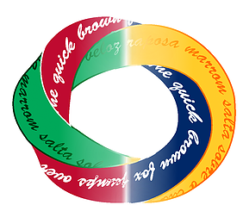 | Danielle Sanchez  Translator, Brazilian Portuguese <> English  Reliable and capable of handling large projects, maintaining quality and accuracy  p: +55 (11) 3042-7438 | m: +1 (585) 290-3019 | e: danielle@danitranslations.com
 |  | daniellesteffen |  | Dani’s Translations (website)
 | Address: Av. Presidente Altino, 71, Indaiatuba/SP, Brazil

SERVICES: translation and proofreading
NATIVE LANGUAGE: Brazilian Portuguese TARGET LANGUAGE: English
TRANSLATION DIRECTION: Brazilian Portuguese > English
English > Brazilian Portuguese

TRANSLATION ACTIVITIES
Years of experience: 5 years
Productivity: 3,000 words per workday for translation and 4,000 for proofreading

SPECIALIZATION
- Energy - Oil & Gas, Electricity, Alternative energies, Equipment
- Engineering - Metallurgy, Machining, Shipbuilding, Chemistry, Aviation, Defense
- Marketing – all fields (Market Research, DBM, CRM, Loyalty Marketing, Business Intelligence, Advertising, etc.)
- Medical – equipment manuals, chapter of textbooks, hospital forms for social services
- Sciences – papers and textbooks of Mathematics, Statistics, Physics, Chemistry and Biology.

SOFTWARE
- CAT Tools: OmegaT and MemoQ, also have experience with Wordfast
- Software: Office suite, LaTeX

OTHER QUALIFICATIONS
- Bachelor degree in Statistical Science –ENCE/IBGE, Brazil.
- Bachelor degree in Molecular Science (not completed) – University of São Paulo (USP), Brazil.
- More than 10 years of experience in statistical analysis in several fields (DBM, BI, statistical modelling, credit risk, pricing analysis, forecast of financial data, demographics, health).

