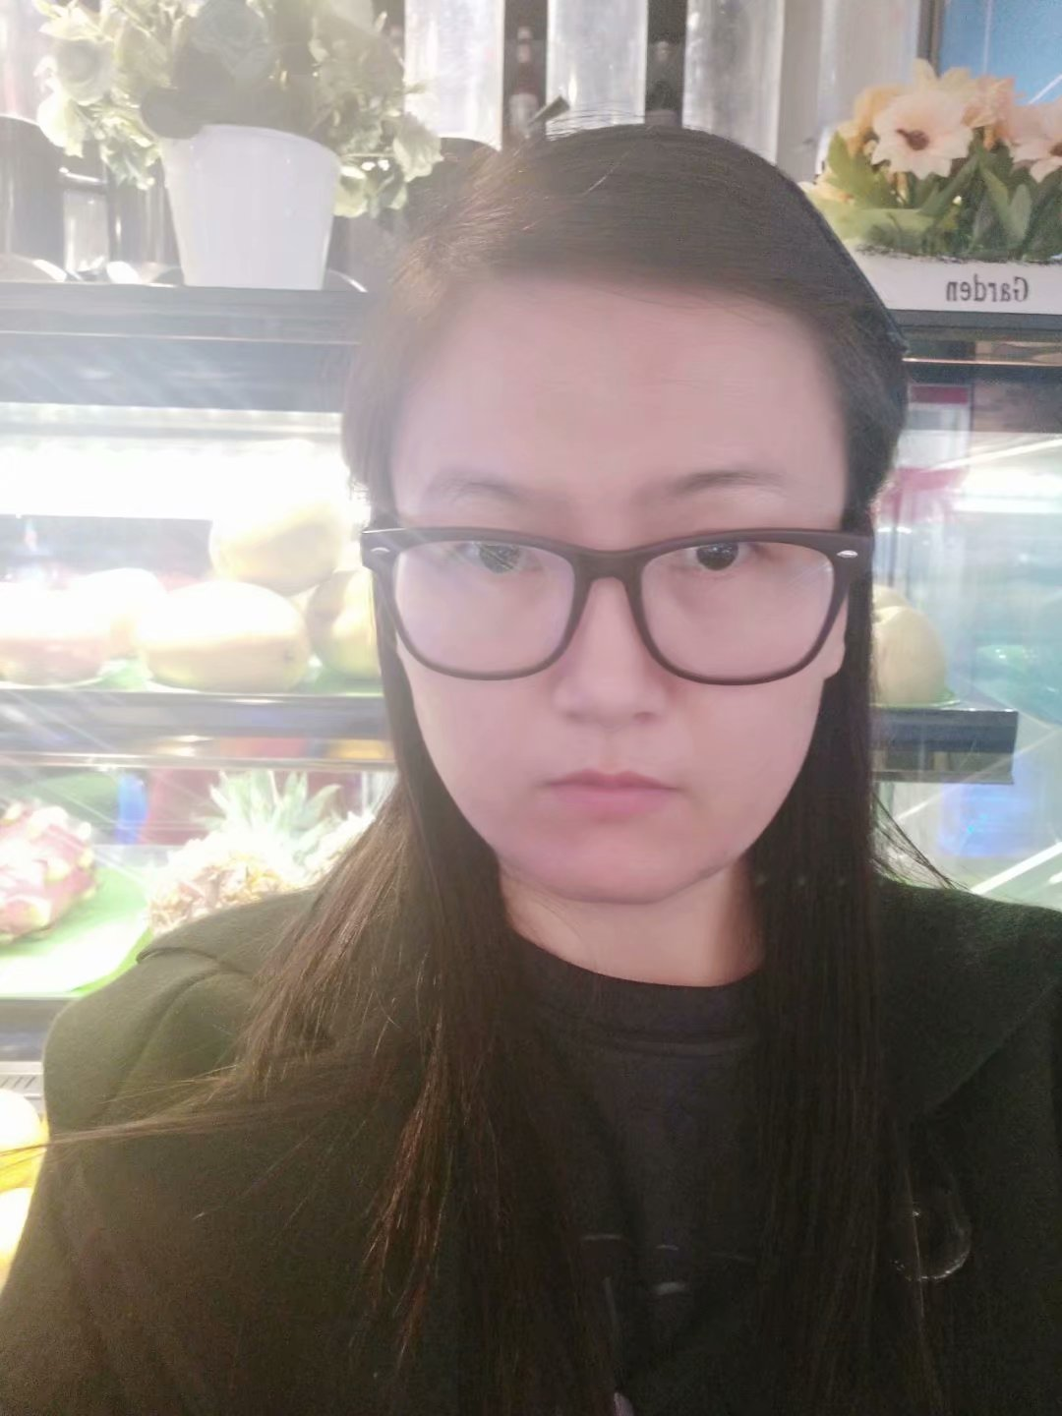
Cuiping Jiang
English<>Chinese (Including Shanghainese, HK and Cantonese)

Personal Information:

Services offered: translation, transcreation, review/proofreading, transcription

Date of Birth: May 12, 1983
Nationality: Chinese
Native language: Chinese Simplified
Country: China
Translation experience since: April 2007
Available during: Beijing, China, UTC+8:00 7am-10pm
Language pairs:
English to Simplified Chinese
English to Simplified Chinese (Shanghainese)
English to Traditional Chinese (Hongkong)
English to Traditional Chinese (Cantonese)
Simplified Chinese to English
Traditional Chinese to English
Capacity:
Translation: 2,000-9,000 words per day
MTPE: 6,000-12,000 words per day
Proofreading/review: 5,000-8,000 words per day
Rate:
Translation: 0.15 USD per source word
MTPE: 0.095 USD per source word
Transcreation: 0.25 USD per source word
Review/Proofreading: 0.085 USD per source word or 85 USD per hour
Transcription: 10USD per minute
Areas of Expertise:
Medical/Pharmaceuticals/Medicine/Life Science/Biotechnology
Automotive
Aerospace
Business/Legal/Finance/General
Tech/Engineering/Machinery
Electronics
Education
Construction
Environment/Ecology/Energy
Science
Social Science
Human resource
Art/Literary/Tourism
Human resource, Government, NGO
Information & Communication Technologies
Patent
Game
Transportation
CAT Tools:
Across Translator Edition
Crowdin
Déjà Vu X3
Matecat
Memsource
memoQ 8.2
Plunet
SDL Trados Studio 2021/2019
SDL Passolo 2018/2011
SmartCat
Wordbee
Wordfast Pro
QA Tools:
Xbench
Verifika
WeChat ID: Colorful79343
Skype: live:.cid.2547ee7583e7bbd5
Email: cuiping-jiang@hotmail.com
My profile and project history on Proz.com: http://www.proz.com/translator/3077501
My profile on LinkedIn: https://www.linkedin.com/in/wenqi-j-a45482196

