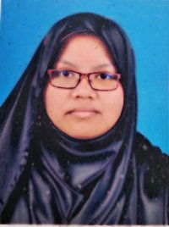

CURRICULUM VITAE

CQISTINA BINTI MOHD FAZIDIN

**PERSONAL DETAILS**

**Phone: +6**0193111456

**E-Mail:** cqistrans.l8@gmail.com

**Address:**18, JALAN 4A, AMPANG JAYA, 68000, SELANGOR

**Skype Name**: Cqistrans.l8

**RESUME SUMMARY**

|  |
| --- |
| * **Current Position**: Student, Freelancer (part time) * **Current Specialization**: Tourism, Travel, Sports, Business, Real Estate, Financial, Software. * **Highest Education**: SPM (Malaysian O-levels) and IGCSE (Cambridge O-levels) * **Years of Experience**: 6 months of translation work as a freelancer * **Translation rate per word**:   English - Malay- 0.04USD per word  Malay - English- 0.04USD per word |

**AREA OF SPECIALIZATION**

|  |
| --- |
| * Questionnaire * Website Content * Brochure / Marketing * General correspondence * Software/ IT correspondence /FAQs/Manual * General |

|  |
| --- |
| * Online Graphic Design Platforms * Financial Platforms * Software for Devices |

**LIST OF CLIENTS**

**PAYMENT METHOD**

-Paypal

-Online Transfer

-Cheque

-Telegraph Transfer

**SOFTWARE USED**

|  |
| --- |
| * Microsoft Office * ApSIC Xbench * Memsource Editor * Smartling Software |