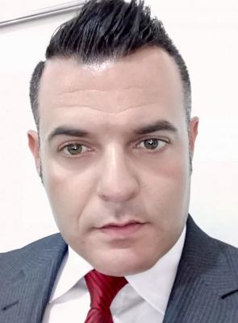 Z智能手机

Motto: A translator is a reader, an interpreter and a creator all in one.

Claudio Pizana Antón

PROFILE

* CONTACT

2012-2013. HSK 5,6. Chinese Proficiency Test (Confucius Institute, Northeast Normal University, China)

1. TEFL. 150 Hours. (British Council Certification)
2. TESOL. 120 Hours. (USILACS, Florida State University)

* CERTIFICATION

• Information Compilation • Tone and Style Setting

• Schedule Management • Timelines Determination

• Research Handling • Quality Standards

• Translation Tools Use • Microsoft Office

* PROFESSIONAL SKILLS

2014-2022. **School Administrator. Scholastic, China (Human Resources)** Work involves oral and written translation from English to Chinese and Chinese to English. I am responsible for written translation from English to Chinese for such purposes as notification regarding school activities, student progress, disciplinary actions, etc. I perform other related work as required.

**2019-2022. Freelance Translator & Interpreter. (Spanish-Chinese-English)** I love working with direct clients, mostly small businesses, non-profits, Chinese and Spanish Police, Chinese Immigration Department and many other entities that have translation needs.

* EXPERIENCE

• Bachelor of Principles and Methods of Language Education (USILACS State of Florida University 2017-2020)

• MA in Teaching Chinese as a Foreign Language (NENU, China 2012-2013)

• MA in Translation and Technologies (UOC, Spain 2021-In Progress)

* EDUCATION
* HOBBIES
* LANGUAGES

Fitness

Swimming

Reading

Spanish: Mother Tongue

English: Proficiency (C1)

Chinese: Mastery (C2)

Resourceful and organized translator and interpreter with exceptional verbal and written communication skills in Spanish, English and Chinese.

Competent in converting concepts from source languages to equivalent concepts in target languages.

+34 651 42 78 17

antonpizana@gmail.com

* OBJECTIVE