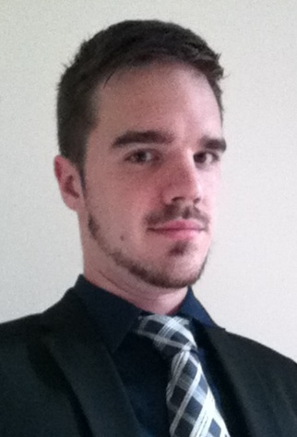
Christopher BANDERS (25 years)
Charles Malek; Sagesse Builind,
Achrafieh; Beirut, Lebanon
Tel. : +096 70 996 408
E-mail : chris_banders@yahoo.de
Nationality: British and German
EDUCATION
Since September 2014  July 2014 | Master of International and European Law, University of Pierre Mendès France (UPMF), Grenoble, France  Master of Arts in Political Science, American University of Beirut (AUB), Beirut, Lebanon  Bachelor of Political Science Minor History , University of Paris VIII, Paris, France  Bachelor of Law, Centre Audiovisuel d’Etudes Juridiques à Distance (CAVE), University of Versailles Saint-Quentin-en-Yveslines, Paris, France
July 2013 | Exchange year in Political Science (Erasmus) , Universidad Complutense de Madrid, Spain
September 2011 | HND Accounting and Finance, French-German Commercial and Business School (EFACI) at Issy-les-Moulineaux
July 2008 | High School Certificate minor Science at the Droste-Hülshoff Gymnasium, Meersburg, Germany
WORKING EXPERIENCE
Since 09/14 | Research Assistant at American University of Beirut , Beirut, Lebanon  - Administrative and research related work  - Teaching and correcting exams
04/14 – 08/14 | Junior Accountant at VIGEL & ASSOCIES , Paris, France  - Updating the Accounts Receivable  - Tax preparation  - Preparation of reportings and annual accounts  - Participation in audits of the Company
09/13 –01/14 | Juridical Secretary at LL Avocats, Paris, France  - Classical secretary tasks (answering phone, mail, archives,etc.c)  - Preparation of the letters for the different French tribunals (TASS, TCI, CRA, CARSAT, URSSAF)
09/11 – 08/12 | Junior Accountant at ECOVIS, Paris, France  - Updating the Accounts Receivable  - Tax preparation  - Preparation of reportings and annual accounts  - Participation in audits of the Company

11/09 – 08/11 | Trainee in the department of Risk and Internal Control at Siemens, Saint Denis, France  - Analyses of the Expense Reports  - Project of updating the financial processes  - Project of updating the Management Handbook  - Various works to ensure financial transparency
SKILLS

Computer Skills:
Microsoft Office (Word, Excel, PowerPoint, Outlook), Accounting Software (SAGE, CIEL), Translations tools (Word East), KLEOS

Language Skills:
German (Mother tongue), English (Mother tongue), French (Bilingual), Spanish (Excellent), Italian (Good), Arabic (Basics), Lebanese Arabic (Basics)

