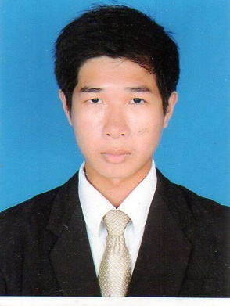
CURRICULUM VATAE

Mr. Leng Cherpheng
Nationality : Cambodian
Date of birth : March 03, 1996
Address : No. 333DEo, Path,
Tek Thlar Quarter,
Sen Sok district, Phnom Penh, Cambodia
Mobile Phone : (+855) 10 752 739
E-mail : lengcherpheng@gmail.com

EDUCATION

2014-2017 : Bachelor Degree at Cambodia Mekong
University in field of International Relations

WORKING EXPERIENCE
- Internee at CamASEAN Youth’s Future (2015-2016)
- Import Document at Lee’s Food Service (2016-2017)
- Translator and Interpreter at Context Translation Service (2017-2020)

SKILL
- Computer: Microsoft Office, Adobe, SDL Trados, Google Translation Tool, Microsoft Leaf, Xliff Translation Tool, etc.
- Translation: Translate English into Khmer and vice versa;
- Interpretation: Interpret English into Khmer vice versa;
- Editing, proofreading

LANGUAGES

Khmer : Native English : Good

REFERENCE
- Mr. Srun Srorn (Founder of CamASEAN Youth’s Future), 093 60 02 34
- Mr. Kong Yara (Project Manager of Media One), 070 74 01 85
- Mr. Hong Phanith (Director of Context Translation Service) 012 345 858

