RESUME
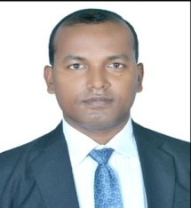 Email: csprasad189@gmail.com CHANDRASHEKHAR PRASAD Mob: +91 9555704620, +91 9507094080
Objective: To Be a Successful professional in a Globally Respected Company and to achieve the objectives of the company with Honesty and Fairness and to Continuously Upgrade My Knowledge and Skills.

Educational Qualification
- Graduation (Bachelors Of Science) 2003
- Intermediate in Science- 1998
- Matriculation – 1996

Other Qualification
- Diploma in Journalism
- Translation and Transcription Expert
- Expertise in Translation.

Work Experience
- Worked as freelance translator/transcriber in 15+ languages worldwide for more than 10 years.

Personal Information
Father’s Name : Mahendra Prasad
Mother’s Name : Smt. Savitri Devi
Date of Birth : 2nd October 1980
Marital Status : Married
Nationality : Indian
Religion : Sanatan
Language Known : Hindi, English,Nepali,Japanese
Hobbies : Listen to Music, Work on Computer

Declaration
All the information given above are true.

Date :21/02/2020 Chandrashekhar Prasad Place : Purnia (Signature)

