RESUME

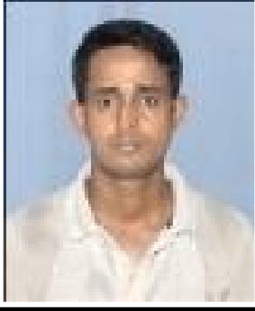

Bikash Bepari
Address:
C/o- Nitai Bepari Bishnupur, Sankardev path, Near Kalimandir, H/no-35
P.O- Gopinath Nagar, P.S.- Bharalumukh Pin No.-781016, District- Kamrup(M),Assam Ph.:- 7662072757
E-mail: bikash.bepari321@gmail.com
OBJECTIVE:

To work in an Ingenious, exciting and challenging environment in a position that has the potential for growth and innovation, where I can utilize and enhance my skills.

STRENGTH
- Quick learner and innovates new ideas.
- Passion for hard work, perfection and success.
- Down to earth practical person with lots of confidence and positive attitude towards life.
- Easily mix-up with people.

EDUCATIONAL QUALIFICATION

EXAMINATI ON | STREAM/ MEJOR | BOARD / UNIVERSITY | EDUCATIONAL INSTITUTIONS | YEAR | DIVISON | %
HSLC | ….. | SEBA | Kahilipara High School | 2005 | 1st | 60%
SSC | SCIENCE | NIOS | KAMRUP ACADEMY | 2012 Dec | 2nd | 48.2%
B.A. | BENGALI | GUWAHATI UNIVERSITY | COTTON UNIVERSITY | 2016 | 1st | 70%

M.A. | BENGALI | GUWAHATI UNIVERSITY | GUWAHATI UNIVERSITY | 2018 | 2ND | 55%
Ph.D | BENGALI | GUWAHATI UNIVERSITY | GUWAHATI UNIVERSITY | PURSUING | ----- | -----
D.el.ed | MATHS, SCIENCE | SCERT | H.K.HAZARIKA COLLEGE | PASSED | A/F | A/F

OTHER QUALIFICATION

- UGC NET QUALIFIED (JUNE, 2019).
- CTET QUALIFIED (PAPER – I & PAPER – II, 2019)
- 1 YEAR PGDCA COURSE OF SOFTWERE APPLICATIONS.
- DEPLOMA OF MOBILE REPARING.

WORKING EXPERINCE

- WORKED AS ISD IN GEE PEE MOBILE COMPANY FOR 1YEAR 6 MONTHS
- WORKED AS A SOFTWERE TRAINER ACW( COMPUTER INSTITUTE) FOR ONE YEAR.
- WORKED AS A MARKETING EXCECUTIVE IN LAVA MOBILE COMPANY FOR TWO YEARS.
- WORKING IN NGO SCHOOL( NON FOR FORFIT) AS A PERTIME TEACHER FOR LAST 1 YEAR.
- WORKING AS TALLY RESOURCE UNDER A 3 STAR PARTNER( JMK COMPUTERS) FOR LAST 9 MONTHS.

HOBBIES

  - Travelling outstations.
  - Listening to music.
  - Reading books.
  - Making friends.

LANGUAGES KNOWN:

- English
- Bengali
- Assamese
- Hindi

PERSONAL PROFILE

Father’s Name : NITAI BEPARI
Mother’s Name : RITA BEPARI
Date of Birth : 01/06/1989
Religion : HINDUISM
Nationality : INDIAN
Domicile : GUWAHTI (ASSAM)
Sex : MALE
Marital Status : Married
Caste : SC
Permanent Address : SAME AS AVOBE

DECLARATION

I hereby declare that the mentioned information is correct up to my knowledge and I bear the responsibility for the correctness of the above mentioned particulars.

Date: Signature

Place: Guwahati 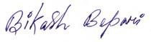
(BIKASH BEPARI)

