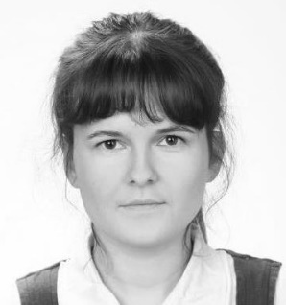
Experience
Berenika
Konar-Mynarek
English to Polish Translator
minuteness, accurateness, reliability
Langscape.pl
Berenika Konar-Mynarek
Kosmonautow 210/8
54-042 Wroclaw
Poland
+48 504 284 969
biuro@langscape.pl
www.langscape.pl
2015-
Veroling
Freelance Translator
Main project:
- translation of a webinar on trading and investing
2014-
Language Wire Translation Services
Freelance Translator
Main project:
- posts on skills of each football team participating in the World Cup Finals in Brazil (on-line betting)
2014-
Alba Translation Agency
Freelance Translator
Main project:
- on-line application for creating websites
2013-
Linearis Translations
Freelance Translator
Main project:
- financial statements of a holding company
2013-
B.T. Columbus
Freelance Translator
Main project:
- animated film voice-over script
2012-
KMC Global Solutions
Freelance Translator
Main project:
- children's story (science-fiction)
2012-
Skrivanek Sp. z o.o.
Freelance Translator
Main projects:
- HR and finance management software workbook
- trade offer on provision of support services in the implementation of improvements and optimisation of manufacturing processes (chemical industry)
- competency model – an in-house detailed presentation of a company (baby food industry)
- recipes catalogue for kitchen equipment manufacturer
- general presentation on the organisational culture for a furniture producer
- academic articles in the field of organisational management

Education
2010-2012
Karol Lipinski Academy of Music
MA in Vocal Art
- Vocal Faculty
2007-2010
Karol Lipinski Academy of Music
BA in Vocal Art
- Vocal Faculty
2006-2009
Silesian University of Technology
MA
- Faculty of Organisation and Management, degree course: Marketing and Management, specialisation: Human Resources Management and Social Communication
2003-2006
Silesian University of Technology
BA
- Faculty of Organisation and Management, degree course: Sociology, specialisation: Social Policy

Certificates
CAE

CAT Tools
SDL Trados Studio 2014, Across

References
Available on request

