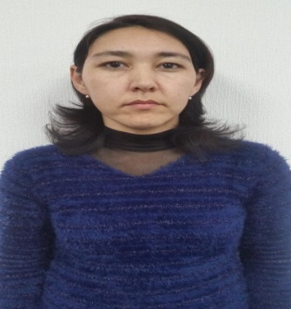
Barno Kamalova
Andijan region , Asaka city, Humo 14/10
170200 Uzbekistan
(998 93 ) 425-23-48
barno89@rambler.ru , barno81@yahoo.com

Education:

- 2003 Fergana State University ( Uzbekistan)
Foreign Department Faculty
Diploma: Roman- German Philology ( English)

1998-1999 Fergana State University
Foreign languages training Center
Certificate.

1987-1997 Andijan Region Asaka city
School # 4
Attestate

Computer skills:

Microsoft Word, Excel, PowerPoint, Outlook, Adobe Photoshop

Languages:

Uzbek (native), Russian ( fluent), English ( fluent).

Professional Experience

Since 11/2015 “GM-Uzbekistan JSV Company” ( Uzbekistan)
Coordination unit , Document control Team
Inspector of incoming letters

- In charge for incoming and outgoing documents control

11/2011 “GM-Uzbekistan JSV Company” ( Uzbekistan)
Coordination section
Assist to 1st Deputy of General Director

- Plant New Models ( Spark, Cobalt) Coordination

- Overall plant reports

- Overall plant ISP’s support

05/2010 “GM-Uzbekistan JV Company” ( Uzbekistan)
Supplier Quality Engineering department
Supplier Quality Engineer

- Business Administration
- Department organization
- Supplier Quality development

12/2008 “GM-Uzbekistan JV Company” ( Uzbekistan)
Coordination Section
Engineer on scientific and technical information ( GM-GMS group member)

  - selection and analysis of information of the section activities

  - provide safety organization of production work and exploitation of office and computer mechanics, keeping the working environment in a proper condition.

  - prepare weekly reports to the Top managements meetings and provide employee with Company Leadership decisions.

  - organize systematical trainings on a new system all over the plant and provide the company management with the training materials

10/2006 - 12/2008 “GM-Uzbekistan JV Company” ( Uzbekistan)
Personnel Development Unit ,Training Center
Engineer on scientific information ( English training development )

  - prepare training materials to the “GMS TRAINING”

  - provide Lead experts with the translations which refer to the new system

08/2003 – 10/2006 “GM-Uzbekistan JV Company” ( Uzbekistan)
Administration department office manager.

  - control and manage with the internal and external documentation

  - prepare daily attendance reports of the department employees

  - prepare weekly reports to the department meetings about company medical, transportation & kitchen affairs, including problem solving documentation.

  - Prepare computer based act statements for the Government on done works in an environment condition of the city.

