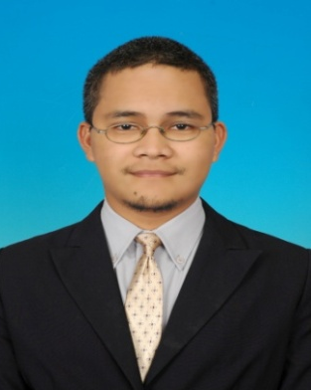
Translator
A reliable and talented translator especially in SAP localization
Able to translate excellently written documents from source language (English) to target language (Malay)

PERSONAL SUMMARY

AREAS OF EXPERTISE
- Translation
- Proofreading
- Documents and certificates
- SAP translation
- Technical paper/report
- Paper/Books/Thesis/ Abstract
- Surveys and Questionnaires
- Resume/CV/Transcripts
- Speech, poems and subtitles, advertisement

PERSONAL SKILLS
Detail oriented
Well organized
Friendly
Fast learner

PERSONAL DETAILS
Mohd Azlan Ahmad
16, Jalan Pulai Indah 5/15,
Taman Pulai Indah, Johor Bharu, Johor,Malaysia
M: +6019-7101304
E: mohd.azlan.bin.ahmad1@gmail.com
Nationality: Malaysian

REFERENCE
Roslindawati Binti Haron
Qalam Hijrah Network
(roslindawatiharon@gmail.com; nda_haron@yahoo.com)
+6017-7669108

WORK EXPERIENCES
Translator (Jun 2007 – present)
Working as freelance for translation agencies and lecturers/students in UTM

Field Service Engineer (July 2008 – August 2013)
Serviced for General Electric (GE) Power and Water Technologies company specializing in chemical specialties supply and after sales services stationed in Lotte Chemical Titan (Formerly known as Titan Petrochemical Sdn Bhd), Pasir Gudang.

KEY SKILLS AND COMPETENCIES
- Fluent in both Malay and English languages
- Excellent in communication skills
- Able to work under tight deadline and pressure
- Highly experienced in Microsoft Office windows

ACADEMIC QUALIFICATIONS
- Meng. Environmental Engineering, Best Student Award, Universiti Teknologi Malaysia (UTM), Johor Bahru, Johor 2016
- Certificate of Translation, Malaysian National Institute of Translation (ITBM), 2015
- Certificate of Translation Editing, Malaysian National Institute of Translation (ITBM), 2014
- BSc. (Hons) Industrial Biology, Universiti Teknologi Malaysia, Johor Bahru, Johor (2004)
- Sijil Pelajaran Malaysia, Sek Tuanku Abdul Rahman, Ipoh, Perak (1998)

