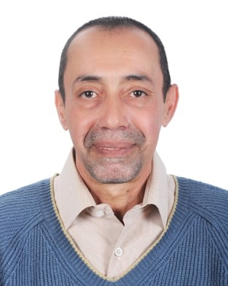

Resume

Ayman Omar Kamel

Date of Birth: 17-3-1962

Tel: ++20 122 3343 092

[Email: aykamel@link.net,](mailto:aykamel@link.net) [aykamel@live.com](mailto:aykamel@live.com)

Nationality : Egyptian

Lives in : Cairo, Egypt

**Summary:**

Highly experienced professional with a diverse background in telecommunications, tourism, scuba diving, graphic design, and industrial assembly. Demonstrated expertise in technical management, translation, tour operations, diving instruction, equipment maintenance, graphic design, web and multimedia production, and client satisfaction. Proficient in English and Arabic.

**Experience:**

**FEBO**

(Maschinenmontagen und Anlagenbau GmbH.) (2011-2023) Representative Office in Egypt

- Managed industrial assembly and machine relocation projects.

**DESIGN HOUSE**

Publishing Agency (1996-2012) Owner

- Founded and operated a successful publishing agency specializing in graphic design for press, web, and multimedia production.

- Provided high-quality product photography services and excelled in printing promotional and packing materials for the pharmaceutical industry.

- Delivered end-to-end services from document development to the final product, including pre- press color separation at the highest quality.

- Enhanced graphic design capabilities with advanced HTML, CSS, JavaScript, and web graphics programming skills.

**Tiran Diving Center** (1992-1996) Owner and Manager

- Established and managed a thriving diving center in Sharm El-Shaikh, Red Sea, Egypt.

- Successfully marketed the diving center at international exhibitions.

**Aquanaut and Sinai divers Diving Center** (1988-1992)

Dive Guide, Dive Instructor, Technical Diving Equipment Maintenance

- Served as a dive guide and dive instructor.

- Maintained technical diving equipment including high-pressure compressors.

**Red Sea Divers Diving Center** (1986-1988) Dive Guide and Assistant Instructor

- Worked as a dive guide and assistant instructor.

**Aqua Marine Diving Center** (1984-1986) Technical Diving Equipment Maintenance

- Maintained technical diving equipment including high-pressure compressors.

- Completed training to work as a dive guide.

**Travco Tourism Company** (1981-1984) Tour Leader and Tour Operations

- Served as a tour leader and managed tour operations.

**Cogemy Contractors** (1977-1980) Translator and Technical Manager

- Contributed to a project to install an international telephone cable between Alexandria and the

Libyan border on the north coast.

- Served as a translator for foreign experts in heavy equipment for excavation and cable laying.

- Trained Egyptian engineers and technicians on modern equipment.

- Served as a technical manager for the project until its completion in 1980.

**Diving Certifications:**

NAUI Instructor (6-1989)

NAUI Assistant Instructor (12-87)

La C.M.A.S One Star Instructor (9-1986) PADI Rescue Diver (3-85)

PADI Advanced Open Water Diver (12-1984) NAUI Open Water Diver (4-1984)

**Education:**

Oxford Diploma in English Literature

Advanced E.G.E Level from the British Consuls

El Slam English School

**Skills:**

Proficient in English and Arabic language Expertise in client satisfaction and communication Effective problem handling

Strong teamwork management skills

Advanced computer hardware and software knowledge

Professional driver for most size vehicles

**Hobbies:**

Underwater and landscape photography

Safari Desert exploration

Water sports such as fishing and sailing

Music collecting

**Travel Experience:**

Extensive travel experience for business and leisure to the United Kingdom, Germany, Switzerland, Italy, and the USA.