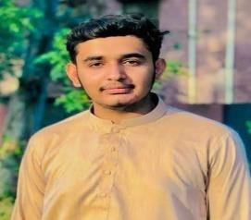
Awais

Ali

Adress
,

City
:
Barkat T
own Stop Wandala

Dayal Shah Shahdara
,

Lahore

Contact # :0301
-
6366257

Email:
ladla2694@gmail.com

OBJECTIVE
- Secure a responsible career opportunity to fully utilize my skills while making a significant contribution to the success of the company
EDUCATION
Intermediate | Government Islamia Collge Civil lines Lahore
Matriculation | Hashmat Memorial School Imamia Colony
SKILLS
- Little Bit Experience About MS World
WORK EXPERIENCE
- First Time
PERSONAL INFORMATION
Father’s Name | Shahbaz Rasool
Date of Birth | 12-02-2003
CNIC No | 35202-1618507-7
Gender | Male
Nationality | Pakistani
Religion | Islam
REFERENCE
- Will be Furnished On Demand

