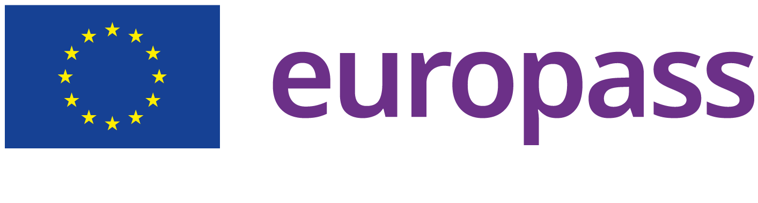

Avgi Platanidi
Athens : Greece
Email: avgiplatanidi@gmail.com
Gender: Female Date of birth: 1985 Nationality: Greek

ABOUT ME

I hold a degree in Greek, Pedagogy & Psychology as well as a certiﬁcate of Proﬁciency in English. I am also bilingual in Greek and English due to parentage.

I have been working as a freelance translator for private projects, companies and established linguistic services for 15 years. I have also worked as a transcriber, voice-over professional, content writer and as an English tutor. I am eﬃcient and thorough, always striving to convey the meaning depending on the targeted audience, aim and local perception. I meet all of my deadlines and, above all, I enjoy and love what I do.

This year I completed an intensive multi-module one-year course in translation as I consider continuous learning and advancement as a necessity, especially in this line of work.

WORK EXPERIENCE
[ Current ] Freelance Translator
I have been working as a freelance translator for private projects, companies and established linguistic services for the past 15 years.

I work mostly with:

- technical and medical content

- general content & press articles

- audiovisual translation (subtitles, voice-over)

- websites (travel, food, art, culture-related texts, etc.)

- academic texts (philosophy, sociology, history, literature, psychology, pedagogy, etc.)

- ﬁnance and law

Some of my recent projects :

- Subtitling for the latest Xbox showcase video

- Translation of the Good Omens show trivia

- Proofreading a 10,000-word technical-content project

- MTPE of ﬁve 100,000-word projects

- Subtitling videos for the Christian Holy City Church in the USA.

- Recording a voice-over project of safety instructions for PoliLingua.

Private Tutor
Country: Greece
I have been tutoring children & adults in English since 2010. [ 2022 ] Travel Guide Writer

Kids Love Greece
Country: United States
Writing the history and myths of famous archaeological sites in Greece, making a family visit exciting, interesting and educating.
One of the articles published:

https://www.kidslovegreece.com/en/insights/visiting-delos-with-kids-everything-your- family-should-know-about-delos/
[ 2021 ] Content Writer
Country: Greece
Translator and creative writer for Ediva, a greek online lifestyle magazine. One of the articles published:

https://www.ediva.gr/eykoles-trofes-gia-yperocho-kai-lampero-derma/? fbclid=IwAR332pEkbpUyQUkB3TbOCrN8szDfvBFcPwQ1TViuF2GRvklXKF17abvA2Iwy

EDUCATION AND
TRAINING

[ 2014 ] Graduate of the Philosophy, Pedagogy and Psychology department of the Philosophy School - major in Greek and Psychology
National and Kapodistrian University of Athens https://en.uoa.gr/ schools_and_departments/school_of_philosophy/
City: Athens
Country: Greece
[ 2023 ] Certiﬁed Translation Expert

EL-Translations Academy
Field(s) of study: Translation
An intensive one-year course in translation which included the following modules:
  - Technical, Financial & Legal Translation
  - Editing & Proofreading
  - Trados, Wordfast & Phrase workshops
  - Terminology & Translation of Documents of the European Union
  - General subtitling & subtitling for the deaf and hard-of-hearing (SDH)
  - Translation Project Management
  - Reverse Translation
  - Machine Translation Post-Editing (MTPE)

Certiﬁcate of Proﬁciency in English
University of Michigan

DIGITAL SKILLS

WordFast Pro | Trados | Matecat | Phrase | Subtitle Edit | VisualSubSync | Microsoft Excel | Microsoft Word | Microsoft Powerpoint | Google Drive | Google Docs | Smartcat | Cubase 5

