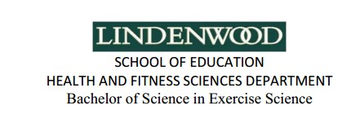

**Aurélien ‘Ali Chéruel**

6 Rue de Rennes

Saint Gilles, 35590, FRANCE

Tel : +337 81 52 30 65

E-mail : [aurelien.ali.cheruel@gmail.com](mailto:aurelien.ali.cheruel@gmail.com)

Date of birth: September 27, 1991

**EDUCATION**

**2013** Bachelor degree in “Exercise Science” at *Lindenwood University, MO, USA*

**2009** Baccalaureate in “Economics and Social Sciences” *in France*

**WORK EXPERIENCE**

**March 2015** Translator (website content) at “HalalBooking” (English to French)

**October.2013** Sale partner+ network marketer at *LR Health&Beauty Systems*

**Jan-May.2013** Personal trainer for a 51 year old individual at *Lindenwood University*

**July 2013**  Internship in *Physical Therapy Facility*

**2010-2013** French tutor at *Lindenwood University*

**2010-11** Laborer (Summer jobs) in *food-processing industries*

**SKILLS**

**Certifications** REPS 3 Personal Training (currently taking)**,** First aid(CPR/AED)

**Languages** French: native; English: fluent ; Spanish: fluent; Arabic: intermediate

**Computer** Microsoft pack office, fast typing pace

**INTERESTS AND HOBBIES**

**Sports** Basketball, Fitness (weight lifting), Soccer, Tennis, Track and Field

**Hobbies** Reading, cookery, hiking

**Travel**  Spain, Senegal, Panama, USA, Tunisia