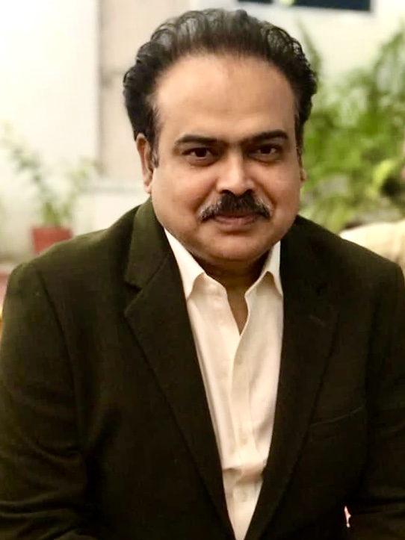

Contact

**Address:**

K-024, Gulshan Vivante, Sector – 137, Noida, U.P. India, 201301

**Phone:**

+91 7840829900

**Email:**

[rumijanu1@gmail.com](mailto:rumijanu1@gmail.com)

**LinkedIn:**

Languages

Hindi

English

Urdu

Hobbies

* Writing
* Reading
* Sports

Summary

Experienced in Content writing, Scripting (Fiction & Non-fiction), Concept Development for TV commercials, Translation & sub-titling both in Hindi and English.

Skill Highlights

|  |  |
| --- | --- |
| * Content Writing * Script Writing (A/Vs) * Translation (English-Hindi) | * Creative Ideation (TVCs) * Team Leader * Service-focused |

Experience

* 15 Years’ Experience In Media in various TV channels and Production houses.
* Worked as Creative Head for a Media Company for around 10 years 2010- 2019, penned more than 200 Documentaries, short films, TV commercials, Corporate A/Vs, Training Films, Fiction etc.
* Worked as News Reader Cum Translator in All India Radio for more than 12 years, still empaneled there.
* Worked as Voice Over artist for some films and documentaries
* Worked as Freelance translator
* Working as Freelance Film Maker, Content Writer, Script Writer, Creative Writer, translator and voice over artist, client include some of the best known media houses of Delhi-NCR
* Won a national award in song writing competition for Students Police Cadet, BPR&D, Ministry of Home Affairs

Education

Masters in Mass Communication from MLC University Bhopal

Arif Fazal Khan