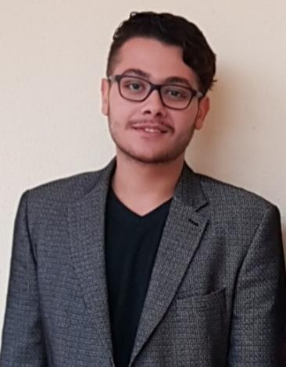

Contact

**Address:**

Erbil – Hawleri Nwe

**Phone:**

+964 0750 8814617

**Email:**

[aranfaxer@hotmail.com](mailto:aranfaxer@hotmail.com)

Languages

English – Fluent

Kurdish – Mother Language

Hobbies

* Reading
* Literature
* Arts
* Cultures
* Pragmatic
* International affairs

Aran fakher

Summary

An educator, translator and interpreter senior. I have specialised in both Kurdish and English writing, and a focused translator with a highly developed understanding of the English language and culture. Meanwhile, I have an aptitude for conveying the style, emotion and content of the English speaker and bringing in-depth ideas of the English speakers in terms of the cultural context. On the other hand, I have a specialization in content writing, pragmatic, social and cultural studies.

Skill Highlights

|  |  |
| --- | --- |
| * Proofreading * Leadership Skills * Culture expertise, awareness | * Innovative * Service-focused * Organised * Effective writing |

Activities

* I, voluntarily, translated three scientific TED video, which can be seen on YouTube too.

*Proof of videos:* [*https://www.ted.com/profiles/24069849/translator*](https://www.ted.com/profiles/24069849/translator)

* Individual English learning instructor .
* Middle school English teacher in mustafa sha’ban school

Education

Bachelor of English education and translator at Koya University

Training

* Completed three U.S online courses that I list below.

1. Fundamentals of digital marketing by Google.

<https://drive.google.com/file/d/1dsM7WqptKWUBa8Q-HD2LftotBykQVhhc/view?usp=drivesdk>

1. The strategy of Content Marketing by the University of California, Davis.
2. Speaking And Writing English Effectively – Revised

<https://drive.google.com/file/d/1-HShszE_IhgdZz5Y9IMgUdweMMT9d5pZ/view>

* Finished a course on culture and Korean culture, and I ended up being the highest score among 30 participants.