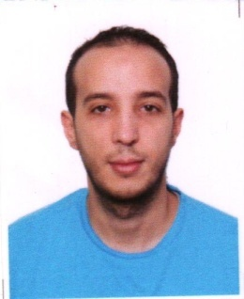
CURRICULUM VITAE
Personal informations
• Full Name: Aniss Chahmat
• Date and place of birth: April 26, 1986 – Annaba (Algeria)
• Address: Coop Ethadhia Oued Kouba 2 – B1 (E2)
• Phone: (+213)552280187
• e-mail: Aniss-chahmat@outlook.fr

Education / Diplomas
07/2007
Boumarouane High school
Annaba, Algeria
High school diploma in Literature and Foreign Languages

2007 – 2011
Badji Mokhtar University
Annaba, Algeria
(B.A) in Translation and Interpreting

02/2016 – 08/2016
Chamber Of Commerce and Industry
Annaba, Algeria
Professional Certificate HSE Supervisor

Languages skills
Arabic : Native language
French : advanced
English advanced :

Experiences
01/2011 – 06/2011
Training P.F.S.O Port of Annaba
Annaba, Algeria
task : Translator
Responsibilities :
Technical translation (Arabic, French, English)

10/2011 – 01/2013
Zala Computer
Annaba, Algeria
Task : Sales representative
Responsibilities :
Organizational Management of logistics,
Local transportation,
Interpreter

03/2013 – 03/2014
Sejong Corporation
Skikda, Algeria
Task : Translator – interpreter
Responsibilities :
Translation and Interpreting

01/2017
Architecture office
Annaba, Algeria
Responsibilities:
Interpreter

SUMMARY COMPETENCE
- Good computer skills.
- Fluent in languages mentioned above.
- Good organization of the workspace.
- stress resistance, and good communication.

