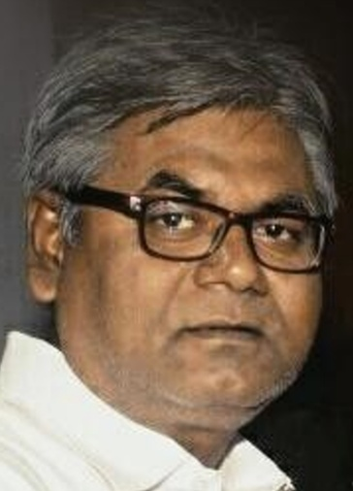
Anil K Gupta
Native Hindi Translator
Natural translation perfectly as per the source
Sincerely adopt guidelines & glossary & maintain deadlines

(https://www.proz.com/profile/2065616)

Contacts
- E-mail: anilgupta2762@gmail.com
- Skype: live:anilgupta2762
- Mobile/Whatsapp: +91 94704 58017

Services
Translation, Transliteration, Transcreation, Transcription, Subtitling, Editing, PMT Editing, Reviewing, Creative Writing, Content Writing

Working Languages
- Hindi (Native)
- Bhojpuri/Chhaparia/Bihari, Bajjika (Semi-native)
- Gujarati, English, Hinglish (Experienced)

Language Pairs
English < > Hindi | Hindi < > Gujarati
English < > Gujarati | Hindi < > Hinglish
English < > Bhojpuri | Gujarati < > Bhojpuri
English < > Bajjika | Gujarati < > Bajjika
English < > Hinglish | Gujarati < > Hinglish

Specialization:
Medical, Legal, Casino Games, Alternative Energy, Banking & Insurance, Cricket, News & Media.

Experienced:
Education, Pharmaceutical, IT, Engineering, Energy, Development, Alternative Development, Market, Economics, Agriculture, Automobile, Transport, Tourism, telecom, Retail Marketing, Art, Culture, Literature, Indian Music, Film, Television, Social Sciences, and more…

Working Tools
SDL Trados Studio 2019, MemoQ Web, Memsource, SmartCAT, Wordfast Anywhere, OmegaT, CafeTran Expresso, Prabandhak, MS Word, Excel, Power Point, Publisher, Page Maker, QuarkXpress, Google Docs, Google Spreadsheet

Experience: 30+ Years
- Background: Journalism, creative writing and poetry writing
- Education: Graduate in Hindi and Political Science from BRABU, Bihar, India.
- Worked as Media Consultant in JDU, with Sh.Nitish Kumar, CM, Bihar (Dec.2014-Nov.2017).
- Career started in journalism as editor, Aman Doot (Hindi Fortnightly) followed by Hamara Mat (Hindi Weekly), SPY (Hindi Weekly), Pratah Kamal (Hindi Daily), Dainik Jagran (Noida, Hisar, Panipat & Rewa), Dainik Bhaskar (Panipat, Noida & Udaipur) & Rajasthan Patrika (Surat, Kolkata, Ajmer & Vapi) in various senior editorial position (30+ years).

Translation Samples
- Sample 1: English: https://www.forwardpress.in/2018/05/by-delisting-journals-ugc-arms-clerks-with-another-harassment-tool/
Translation in Hindi: https://www.forwardpress.in/2018/09/patrikaon-ko-soochee-se-hata-kar-yoojeesee-ne-klarkon-ko-thama-diya-ek-aur-utpeedan-ka-upakaran-2/
- Sample 2: English: https://www.forwardpress.in/2018/05/the-real-cost-of-the-7th-pay-commission-bonanza/
Translation in Hindi: https://www.forwardpress.in/2018/05/kaun-bhar-raha-hai-satave-vetan-ayog-ki-asali-kimat/
- Sample 3: English: https://www.forwardpress.in/2018/09/economic-status-not-relevant-for-reservations/
Translation in Hindi: https://www.forwardpress.in/2018/09/economic-status-not-relevant-for-reservations-hindi/

Recent Works
- Trans-creating cricket news articles (English > Hindi) for https://www.soaringsixes.in/
- Alt News (https://www.altnews.in) : translating articles from English to Hindi regularly which publish in it’s Hindi edition (https://www.altnews.in/hindi/)
- Content writings in Hindi for a Casino Game website through Babel Translation, USA (http://www.rebuildbabel.com/).
- Flo Health Inc., USA (http://flo.health/): website localization on SmartCAT
- Icecat NV (Certified content partner of Wallmart): marketing related localization project.
- Language Aide Pv t. Ltd. (http://www.languageaide.com): translation of QC Chemist questionnaire.
- Translation of some science and maths papers for an IIT JEE preparation institute.
- Easytrans24, Germany (http://easytrans24.com): website localization on Memsource & a rental agreement.
- http://synergium.com.ua (Lithuania): A tweeter project.
- Medaz Neuro Super Speciality Hospital, Patna: translated brochure.
- East Localize, Egypt (http://www.east-localize.com/): editing of a translation work of localization of a city tour project for Haj pilgimis at madina.
- eSenceDesk (http://www.esencedesk.com): translation of some legal and election materials of Law & Election departments of USA.
- Vision Enterprises: Subtitling of some govt of Bihar documentaries & SuScript writing for documentaries on Jiivika (5min.) & Tourism (3min.) for Govt. of Bihar.
- JSQUAD Language Services (http://www.jsquadlsp.com/): translations of power point presentation, website localization &sound track text of a renouned museum in India.
- Lingo Chaps Translation Services India (http://www.lingochaps.com): translation of some insurance articles.
- Ukti Language Services (http://www.ukti.co.in): translation of some promotional material of JCB manufacturing company.
- DMACHS Technologies Pvt Ltd (http://www.dmachs.in): translation of some texts of a political strategy & campaign company (ppt) & website localization.
- Campaign strategist Pvt Ltd: Field Survey Analysis of two assembly constituencies of Chattisgadh & one assembly constituency of Odissa.
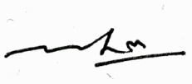
(Anil K Gupta)
Address: Sambal, Near Zenith Petrol Pump, Gunnipur, Hajipur Road, Muzaffarpur 842002, Bihar, India

