Ani Khachatryan

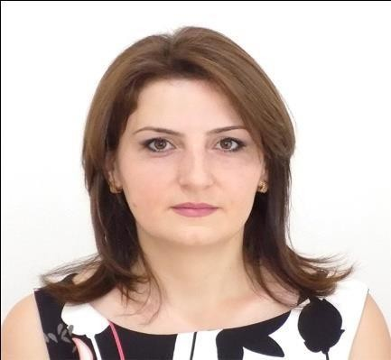

29 Mamikonyants 5, Yerevan
Cell-phone (091) 700082
E-mail: ani700082@gmail.com

Education
2017- 2018 American University of Armenia (Certificate in Translation)
- English for translators
- History and Theories of Translation
- Practicum in Translation
- Consecutive and Simultaneous Interpreting
Summer 2005 Summer Language Courses for Foreign Students,
University of Malaga, Spain
- Spanish in the media
- Contemporary art
- Geography of Spain
- Islamic and Medieval art
Certificate obtained

2003 Language Certificate /Diploma Basico de Espanol/ obtained from the University of Cervantes

2003-2005 State University of Yerevan
Faculty of Roman-Germanic Languages
Spanish Department
Master of Spanish Language and Literature

1999-2003 State University of Yerevan
Faculty of Roman-Germanic Languages
Spanish Department
Bachelor Degree (Diploma with Honor)

1989-1999 Secondary School # 82, Yerevan

Professional Experience
Fabruary 2020 - Spanish speaking sales and customer support manager
Montari LLC
May 2019-2020 Translator of Spanish
State Migration Service of the RA October 2019-2021 Translator of Spanish
Armenian Red Cross Society
October 2019-2021 Translator
Mission Armenia NGO
October 2018 -2020 Law translations for "Krtaran Sona" educational and
consulting center

May 2018 Interpreting (English to Armenian) at the American University of Armenia
Lecturer Hayarpi Papikyan about Mother Armenia: Educating the patriotic Armenian woman in the XIX century

March 2018 Interpreting (English to Armenian) at the American University of Armenia
Lecturer Liliana Edilyan presented Gurgen Edilyan’s letters from exile compiled in a volume titled Speak, Letters

April 2018 Translations for Civilnet.am news website

2017- 2018 Translations for Iravaban.net news website September 2014-2016 Armane Yerkir LTD Incoming tour manager
September 2014-2016 Project and operations manager at Modd Events Armenian-

French Company-Freelance

May 2014 Consecutive translation at the Embassy of Argentina

2004- 2014 Interpreter/Translator
“Armenia” private television studio

2003-2004 Lecturer of Spanish,
“HayBusak” private University, Yerevan

January- September 2003 Courses for guides

“Menua-tour” company,
Certificate obtained

May- July 2003 Lecturer of Spanish,
“Topchayn” language center

January- May 2003 Lecturer of Spanish,
“VLT” language center

April-June 2002 Center of Leadership Development

July 2002 Interpretor/Translator
for the Spain National football team

May 2004 Consecutive translations for <Caritas> Armenia

Computer Skills Windows 95, 98, 2000, XP,
MS Office (Word, Excel, Access, Power Point)

Capabilities Excellent communicational skills Excellent organizational skills Computer skills

Languages Fluent in Spanish, English, Armenian and Russian Good knowledge of French

References Furnished upon request

