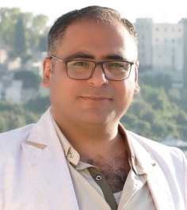
Name : Anhal Adnan Ali
Address : | Sheikh Saad / Tartous / Syria | E-mail : | anhaladnanali@gmail.com
Mobile : | +963-0981380981

- Personal Information :
Marital status : | Married | Nationality : | Syrian
Gender : | Male | Date of Birth : | 27 September 1981

- Objective :
- Working in a job environment where I can be active. Moreover, learning new skills which make me get better and better within my new working environment.

- Education :
- Bachelor’s degree in English Language and Literature (Tishreen University 2008)

- Qualifications :
- International Computer Driving License /ICDL/

- Skills :
- Good communication skills, analytical thinking, working under pressure, good user of the computer programs and Internet.

- Languages :
- English : Upper Intermediate.
- Arabic : Mother tongue.

- Work experience :

- Teaching in private and public high schools.

- Private teacher for beginner and advanced students for fifteen years.

- Teaching at an institute of Language for five years.

- Teaching Headway course for ten years.

