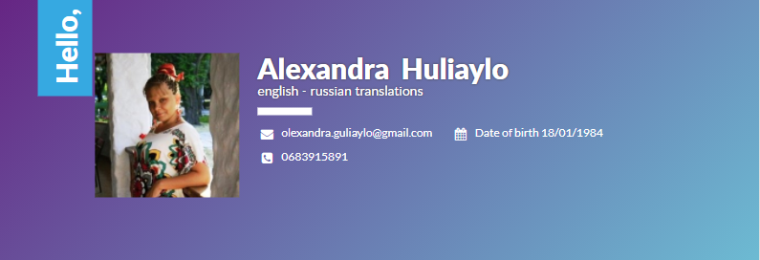
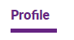
Hello, my name is Alexandra, I’m 36 years old. I’m single with 2 children of 16 and 5 years old. I‘ve learnt English since I was a child with two attractive American guys. I used to work as an English teacher for special children, but 7 years ago my life seriously changed and I started working as a freelance translator. I would like my situation to be clear for my future clients. My elder daughter has Autistic Spectrum Disorder, that’s why I work as a freelancer. But if I took a job, I would do it. Also I perfectly know my native Russian, so if you need a professional, readable and understandable translation from English into Russian, you are always welcome. My themes are general, beauty and health, psychology, personal developing, spiritual, astrology, education. And I don’t mind if I do something new, that I’ve never tried, but it can take longer. Themes that I can be interested in are medicine, blogging, music, handmade, e-learning, computer games, books in general.
1991-2001 – is a school time. I left school and got my school leaving certificate in June 2001. During my school time, I was improving my English due to my pen friends from the USA.
In October 2003 I started my university education at the Moscow State Open University and was graduated in June 2008 as a linguist, translator.
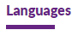
English – I have Advanced level of English, but I’m not a native-speaker.
Spanish – basic. I haven’t used this language for more than 10 years. I can just read and translate with a dictionary.
Russian – I’m a native-speaker, and I know my language very well. My mother used to work as a Russian teacher, I had to be good at it.
2006 – 2013 – a private English teacher for special children (with different disorders).
Since 2013 – a freelance translator.
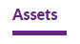
I’m a responsible person. If I take a job, I will do it.
And I enjoy my work, so I work to the result.
I’m not taken up with money, but with my work. So I haven’t got fixed prices for my work. The price depends on how I’m interested in its theme and quantity of pages or words. The minimal price is 0,02 euro per word.
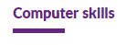
I know and can use a lot of computer programs, and any new program is not a problem for me, except Photoshop .
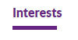
I have a lot of interests in my life, such as Chinese metaphysics, tarot, psychology, medicine, music, knitting, DIY and so on.

