Alberto Cury

Rua Parque Domingos Luiz, 175
02043-081 – Sao Paulo – SP – Brazil (GMT -3)
Phones: +55 (11) 97684-7842 (Mobile) and +55 (11) 2979-1369 (Office)
E-Mail: contact@betaplantranslation.com
Skype: alberto_cury
Site: www.betaplantranslation.com

English & Portuguese Linguist

Career Highlights:

- Career developed in Sales, Application Engineering, Technical Services & Marketing
- 30+ years working for companies such as Emerson, Otis, Honeywell, Invensys and Allen Bradley
- Specialist in Marketing, Sales, Refrigeration and HVAC, Industrial and Building Automation

Translation Experience:

- Over 4 million words translated
- Proven experience translating technical manuals and system screens
- Daily output: ~ 6k words (depending on subject field)
- English teacher
- Portuguese native language – Brazilian variant

Fields of Expertise:

- Banking & Finance
- Legal, Contracts & Patents
- Electronics & Electrical
- Engineering
- Automation, HVAC & Robotics
- IT - Hardware & Software

CAT/QA Tools:

- SDL Trados Studio 2015
- MemoQ 2014
- Wordfast 2012

Education:

- Telecommunication
- Business, HR & Marketing
- Website & E-Commerce
- Machinery, Mechanical & Automotive
- Medical & Pharmaceutical
- Technical Manuals & User Interface
- Passolo 2011
- Memosource
- Xbench

- Cultura Inglesa – Translation Course – 2013
- IBMEC – MBA – Business Administration – 2001
- FGV – Specialization in Marketing – 1995
- FAAP – Post graduate in Systems Analysis – 1984
- FEI – Bachelor’s Degree in Electrical Engineering – majors in Electronics – 1981
- CCAA – Graduation in English – 1980

Translation Projects Developed:
To see an updated job list, please visit: www.betaplantranslation.com/

Translation Referrals:
To see an updated referrals list, please visit: www.betaplantranslation.com/

Alberto Cury Page 1

Professional References

1) Tabassum Mulla – Senior Project Manager – Translate Plus – UK

5 Waterside, 44-48 Wharf Road - London N1 7UX, UK e-mail: TabassumM@translateplus.com
www.translateplus.com
Phone: +44 (0)20 7324 0995 / Fax: +44 (0)20 3642 9032

- Maria Peterson – Translation Manager – Interface – France

530, route de Préaux - 76160 Roncherolles sur le vivier e-mail: interface.trad@interface-sa.fr
www.interface-sa.fr Phone: 02 35 12 33 62

- Bozana Peric – Owner – Technical Translation Services – USA

37841 Euclid Avenue Willoughby, Ohio, USA 44094
e-mail: tts@techtranslation.com www.techtranslation.com
Phone: +1 440-942-3130 - Fax: 440-951-6197

- Kelly Martin – Project Manager- Interpreters & Translators – USA

e-mail: kmartin@ititranslates.com
www.ititranslates.com
Phone: (860) 730-6153 - Fax (860) 432-5357

- José Amorim Gomes – Owner – Translation Services – Portugal

Rua Manuel Salgueiral, 216 - 7° DP 4400-213 Vila Nova de Gaia - Portugal e-mail: jgomes@joseamg.com www.joseamg.com/en
Phone: (+351) 223 709 073 - (+351) 917 868 062
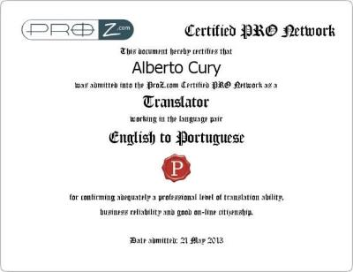
Alberto Cury

Page
2

Certified Pro Translator:

