Adril Yasran
English to Indonesian Translator | Transcreator | Copywriter

Versatile, reliable and passionate linguist with professional experience. Demonstrated track record of successfully providing outstanding service to diverse clients from small private to large high profile projects. Diversified skills include translation, transcreation, localization, copywriting, subtitling and LQA.
address: Kuala Nyiur 2 Blok B No.15, Kel.Pasir Nan Tigo, Kec.Koto Tangah, Padang, Indonesia 25171
tel: +6285263389092
e-mail: adrilyasran@gmail.com, adrilyas@gmail.com
skype: adril.yasran
nationality: Indonesian
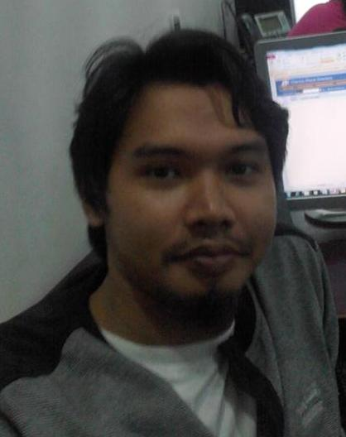

:::: Education

2006 – 2011 Bachelor of Arts in English Language and Literature, Andalas University, Padang, West Sumatra, Indonesia

:::: Language Pair

English > Indonesian

:::: Affiliations

Member of Bahtera (Indonesian Linguist and Translator’s Mailing List)
ProZ - http://www.proz.com/profile/2242349
TranslatorsCafe - Adrilyasran.TranslatorsCafe.com
Also member of Translation Directory - http://www.translationdirectory.com/translators/english_indonesian/adril_yasran.php
LinkedIn - https://www.linkedin.com/in/adril-yasran-20b293101/

:::: Employment/Professional Experience

2019-present Transcreator/Copywriter at Mother Tongue Writers
2018-present Localization specialist at KAYAK
2017-present Transcreator/Copywriter at Oliver Agency
2017-2018 Translator/Linguist at Bridgeway Translations
2015-2017 Linguist at Welocalize
2015-2017 Evaluator/Localization at Lionbridge
2014-2016 Web content writer/editor – Self Employed
2011-2014 Staff at PT Netmarks Indonesia
2011-present Freelance translator

:::: Tools/Software

Windows 10 (OS), Ms Office, OpenOffice, WPS Office (Word Processor)
OmegaT, Wordfast, Transifex, XTM, Poedit, Memsource, Smartcat, Trados (CAT Tool)
Adobe Reader, Oxford Advance Learner’s Dictionary, Kamus Besar Bahasa Indonesia (KBBI)

:::: Specialization

General, marketing & advertising, travel, tourism, IT, video game (in-game text such as storyline, dialogue and item description), manual, journalism, media, sport, education, literature, religion, entertainment, language & linguistics, economics, movie, website and app.

:::: Translation, Transcreation, Writing and LQA Projects

- Translation/localization of websites, apps and marketing contents (KAYAK, momondo, Cheapflights and Hotelscombined)
- Translation of yearly report Creators for Change Booklet 2018, Thank you Card (YouTube)
- Translation/Subtitling of Google products (Stories, LCS Programmatic Guaranteed, Google Maps, Edu)
- Translation of Technology and Manufacturing Webinar (Microsoft)
- Transcreation of marketing contents, website and style guide creation for PayPal
- Marketing and app translation/LQA review for Yahoo products (Yahoo Mail, News, Finance, Sport and Search), HuffPost, Straight2Bank app (Standard Chartered), Cleanipedia website (Unilever)
- Transcreation of Chinatown printed guide (Singapore Tourism Board – STB), Tourism Australia, Village Hotels, Wego, Japan Airlines (JAL) and Turkish Airlines
- Cross-market copywriting (transcreation) of TVC script, promotion, ads campaign and other marketing materials for HP products, Panasonic, Pond’s, Lifebuoy, Pepsodent, Closeup, TRESemmé, Sunlight, Dove, Vixal, CLEAR, Sunsilk, Kinder Joy, Pringles, Starbucks, Whiskas, Kiwi, OCBC, DBS, Allianz, Red Hat, Canon, ExxonMobil, LinkedIn, TikTok, Snapchat, JobStreet, FedEx, SEATCA, Grab, AMD Radeon and Mozilla Firefox
- Translation of Study Materials (Frisian Flag - INSEAD), case report (Parkway Hospitals Singapore Pte Ltd), Q&A (Changi Airport), training (Pfizer)
- App and video game localization of Vainglory (Super Evil Megacorp), AoV (Arena of Valor), PUBG Mobile (Tencent Games), Hundred Soul (HOUND 13), Perfect Swing
- LQA review for clients such as Orchard Hotel, Jeweluxe, CodeBerry (UX testing), NEC, Comfort, adidas and Dell
- Evaluator/Web research at Lionbridge
- Translation of media release for Airwallex, Nexusguard, Infor, MSIG Biodiversity Website, Ruckus Networks, Alliance To End Plastic Waste, Avnet Asia Pacific, Hong Kong Tourism Board, Cohort plc, BE@RBRICK, DHL, Watts Miners, Fave, Kuehne + Nagel, Comasia Limited, AppsFlyer and more.

