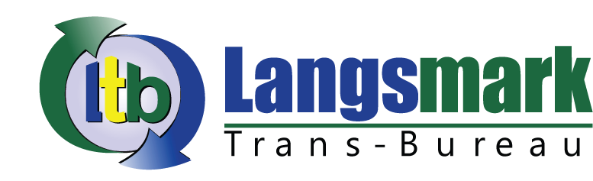

PROPOSAL FOR CONTRACT
Multilingual Translation, Conference Interpretation, Business Support Services

Year 2017

Profile
Langsmark Translation Bureau is a multilingual translation, conference interpretation and business support services agency established in 2015 and has been registered with the Registrar General’s Department under the Company Act, 1962 (No 151) with the Registration No. BN194362016, VIZ, under the name “Langsmark Enterprises”.
Expert in project management, rapporteuring services, facilitation of meetings, workshops and conferences, staff recruitment, coordination of conferences, supervision and research, Mark Koffi Mawunyo Obidiaba, Managing Director of Langsmark is a professional Translator and Interpreter and a member of the Ghana Association of Translators and Interpreters (GATI). He holds a Bachelor of Art (BA) degree in Modern Languages from the University of Lomé (Togo), and another Bachelor of Arts degree (B.A) in Translation from the University of Ghana, Ghana Institute of Languages, School of Translators. He is also a holder of certificate in Resource Mobilisation and Proposal Writing from the West Africa Civil Society Institute (WACSI) Ghana, and a certificate in Interpretation from the Ministry of foreign Affairs, Regional Integration and the Diaspora of the Republic of Benin. He, moreover, holds other certificates in Understanding Elections and Civic Responsibilities and Understanding Climate Change both from the Young African Leadership Initiative Network, Washington DC.
He formerly worked with City Network Language Centre as a Translator and Interpreter and with the West Africa Civil Society Institute, a Regional Non-for Profit Organisation as an institutional Translator-Interpreter and Programme Assistant.
He speaks fluently three international languages (French, English and German) and has knowledge in Spanish and Portuguese.
Mission: Langsmark Translation Bureau is a company that seek to providing adequate and comprehensive translation services, conference interpretation and other business support services to individuals, the private and public sector.
Vision: The company seeks to promote an enabling environment to foster growth, increase collaboration between Langsmark and its clients and partners and sustain Langsmark’s position as the hub of language translation, conference interpretation and business support services in Ghana and beyond.
Objectives: Langsmark’s objectives are divided into three folds: (1) Serve as a liaison between corporate bodies, public institutions and the company in the areas of language translation and conference interpretation; (2) Provide the highest quality of services that are relevant to the needs of organizations and institutions; (3) Develop effective project facilitation strategies to enhance workshop, conference and meeting planning for organizations and institutions.

Expert Areas
Langsmark Translation Bureau focuses more on two main areas, which includes:
- Multilingual Translation and Conference Interpretation:
- Translation of highly technical documents such as reports of court proceedings, medical reports, researches, travelling documents (Passport, Birth Certificates, Power of Attorney…), annual reports, financial reports…
- Conference interpretation during conferences, workshops, court hearings, meetings…
- Business Support Services:
- Conference/ workshop rapporteuring services,
- Conference secretarial services,
- Recruitment of multilingual staff.
- Catering, decoration, meet and greet at the airport,

Past Clients/ Partners
- Redsea International: Provided translation Services to the company, September 2016.

- West Africa Fertiliser Association (WAFA): Provided the Association with Conference Interpretation services during its two-day establishment meeting held at Fiesta Royale Hotel, Accra-Ghana, September 2016.

- Africa Lead/ Ministry of Food and Agriculture: Provided consultancy in rapporteuring during the Public Validation of the Annual Progress Report on the New Alliance and Grow Africa Cooperative Framework Agreement at Alisa Hotel in Accra, Ghana, August, 2016.

- Africa Lead/USAID: Provided consultancy in rapporteuring during CAADP/NSA workshop held at Holyday Inn Hotel in Accra, Ghana, April, 2016.

- International Third Sector Research, African Network (ISTRAN): Provided consultancy in Rapporteuring during its Regional Research Conference, held in Mensvic Hotel, Accra, Ghana, March, 2016

- West Africa Civil Society Institute: Provided translation services, conference interpretation, conference and workshop facilitation, coordination, rapporteuring services to the Institute, September 2015 – August 2016.

- Accra Magistrate Court: Provided consecutive interpretation services to the court during court hearing, July 2015.

CONTACT INFORMATION
Name of Company: Langsmark Translation Bureau (LTB)
Address: G 44/7 LA-TRADE FAIR, BOX: TF 7, Trade Fair, Accra-Ghana,
Telephone TEL: +233-245939588/ +233-208079833
E-MAIL: ltb.gh17@gmail.com
Head of Company’s Name, Telephone Number and Email Address: Mark Koffi Mawunyo Obidiaba, Obi.marc@gmail.com, +233-245939588/ +233-208079833
Address of the Executive Secretary: Ab 23/577 Lapaz, Mikilou Koumako Cossipe, cmikilou@yahoo.fr, +233 244878760
Office Location: La, Trade Fair, Accra-Ghana

