Mohammed Metwally
Dentist, English Arabic translator, & English tutor. In my fourth decade, single man, like reading, watching news and historic channels, and have my own writings in Facebook and You Tube media.
I aim to make a change in my community, try to achieve a success, make an impact, and leave a good memory. That could be accomplished by undergoing through many studies; raising my intellectual skills, hard working in my fields, and gaining as maximum experience as I can get.
Social activities are one of my preferred time investment, meeting with new people, getting introduced to new cultures are really fascinating. Books and movies are windows to others; so I try my best to extract all spiritual meanings behind.
Mohammed Metwally
Mob. & whatsApp.: +2/01278907181
Email: face.onmars2017@gmail.com

Curriculum Vitae
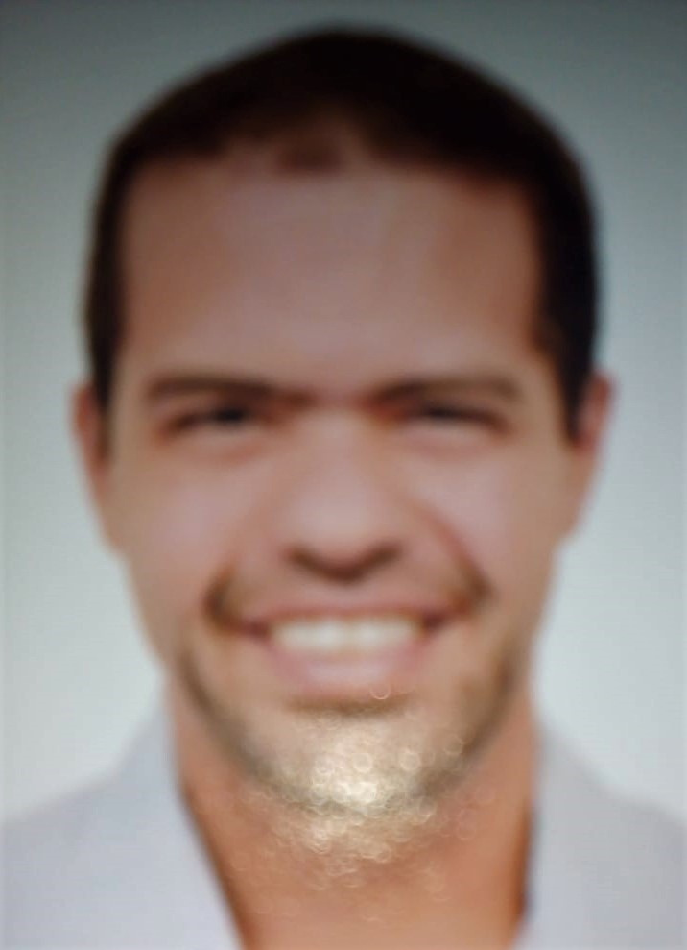

Name: Mohammed Metwally Abdel Aziz
Date of Birth: March 4th 1982
Address: 31st Ahmed Hishmet Street, Zamalek, Cairo, Egypt.
Phone & WhatsApp.: +2/01278907181
Email: face.onmars2017@gmail.com
CERTIFICATES:

QUALIFICATION | GRADUATION YEAR | PLACE OF GRAD. | GRAD. EVALUATI-ON
Bachelor of Dentistry | May 2003 | Cairo University | Good
Bachelor of Arts, English Dept. | July 2017 | Cairo University, free education. | Good
Master (1st part) in Pedodontics | 2008 | Cairo University. | N/A
TEFL Diploma | July 2016 | CLT | Very Good

PREVIOUS EXPERIENCE | DURATION
Dentist at CTA Med. Dept. | 2005 – 2016
English Instructor | 20016 – 2018
English Arabic translator | 2016 till now
CRA at TP | Jun. 2019 till Oct. 2019
TEFL: Teaching English as a Foreign Language.
CLT: Cairo Language Center.
CRA: Call Representative Agent. TP: TelePerformance.

