Who are we?
ELC GROUP has over 14 years’ experience with providing high-quality, cost-effective solutions in translation and interpretation. For this, we have relationships with more than 1,000 freelancers from many different areas of expertise, in addition to a dedicated Project Management team responsible for the coordination with the translators and reviewers.

A standard of quality

ELC Group has experience in many different fields of expertise for many clients and in many languages. Our translators are chosen according to their speciality and knowledge in each technical subject area. They translate in their native tongue. Furthermore, all our translations are verified by a second linguist in order to provide you with the best quality.

Assessment
Translation
Proofreading
In House Review
Quality Assurance

- Comprehensive assessment of your request
- Quotation
- Upon approval by the Client, an experienced project manager assigns the request to an industry & country specific Translator

- The project is then assigned to an equality qualified Proofreader that will cross check the source with the target file provided by the Translator.
- The proofreading allows to make sure of the accuracy of the translation
- The Project Manager does a final check regarding the quality of the final translation, request a third party opinion if needed
- Final check & formatting done internally
- Finale translation
delivered to the Client
- ELC GROUP will remain available in case questions arise, including if modifications are required

A fast turnkey solution…
With offices and translators all around the world, we offer you high quality while meeting your deadline.

… with great simplicity
We offer a centralized solution to simplify the overall translation process.
Regardless the nature and size of your projects, we provide you with a central contact to manage them.

More than just translation, we provide you a localization

A literal translation, even of high quality, may not be enough. You want to reach your suppliers, clients and commercial partners in the best way possible. We will deliver you a translation adapted to the local culture of the targeted region for a better quality of the result.

Out tools
  - SDL TRADOS
  - Management of the translation memories
  - Elcito.com, online platform created in order to facilitate the project management between you and us
  - Adobe Illustrator
  - Adobe InDesign
  - Adobe Photoshop

ELC Group, a global footprint

United States 1500 Market Street 12th Floor, East Tower Philadelphia, 19102

Czech Republic Karolinská 650/1, 18600 Prague 8, Prague

Romania
Emile Zola Street, No. 1, Ap. 23 C, Cluj – Napoca 400193

United Kingdom (HQ)
Regus House, 1010 Cambourne Business Park, Cambourne,
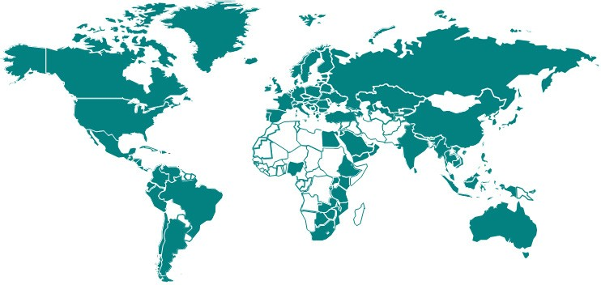
Cambridge CB23 6DP

China

India 309 Morya Estate, (3rd floor, opp. infinity mall), New Link Road, Andheri (West), Mumbai 400053

India
412, Sarthink Square,
4thFloor, Nr. GNFC Info Tower,
S.G. Road, Ahmedabad –380054
New Zealand
ELC GROUP/PSR
Level 11,
48 Emily Place CBD,
Auckland City 0010

Russian Federation
Central Offices City, Northern Tower
10 Testovskaya St., Entrance 1,
Office 1949
123 317, Moscow
Zhixin Lidu garden City,
No 199, Tai Ping Yuan, Middle Six Road, Wuhou District, Chengdu, Sichuan

Contact

Daniel Bruck

Business Development Executive

daniel.bruck@elc-group.com
+420 226 251 462

ELC GROUP s.r.o | www.elc-group.com | Karolinská 650/1, Prague 8, 18 600, Czech Republic | VAT: CZ24248321

