DEA-IN Consulting
(Company for trade, services and consulting DEA-IN CONSULTING DOOEL Skopje)
PIC: 912276562
EuropeAid ID: MK-2017-FNV-1804236829

ABOUT US
Experts from various backgrounds and with diverse professional experience came together to create DEA-IN Consulting. Together we are stronger, and we can build a better world with you.
DEA-IN Consulting provides administrative, organizational and expert services in key areas. The DEA-IN Consulting team is focused on developing a better and more sustainable future together with its partners and clients. We have highly educated experts dedicated to essential areas with a focus on solving challenges related to economy, employment, environment, security and public safety, energy and societal change, all of whom are able to provide tailor-made services to clients.
DEA-IN Consulting partners with clients from the public and private sector supporting sustainable practices and institutional growth with project planning and management, expertise, training, innovation, research, analysis and strategy planning and implementation.
DEA-IN Consulting is based in Skopje, Macedonia.

AREAS OF EXPERTISE
- Democracy and secure societies
- Employment
- Entrepreneurship
- Environment
- Gender and social inclusion
- Learning & Development

SERVICES
- Project management. Project proposal setup, partner finding, proposal writing and evaluation and management of financial, technical assistance, on desk and field project activities. This sector focuses primarily on EU founded projects from H2020, COSME, EUREKA, Creative Europe, Erasmus+, Programme for Employment and Social Innovation (EaSI) and other EU funded, regional and bilateral programmes.
- Studies and surveys. Conducting scientific and tailor-made market research analysis and surveys with full reports.
- Learning and Development. Organisation and facilitation of seminars, conferences, training programmes and workshops, including all logistical aspects.
- Financial and Tax consultancies. Providing clients with accounting advisory services.
- Business planning. Preparation of business plans and strategies.
- Tenders. Preparation of business tender documents and support throughout the application process.
- HR & recruitment. Management of the recruitment process, from advertising postings to initial interviews, including recommendations of suitable candidates for our foreign clients.
- Translation and proofreading. Written, consecutive and simultaneous translation services, proof reading and copy-editing in all languages by court certified translators.

TEAM
Elena Rajkovchevska is Founder and Manager of DEA-IN Consulting. Ms. Rajkovchevska’s background includes earning a Bachelor in Hotel Management and Gastronomy from The Institute of Hospitality Management in Prague, and a Master degree of intellectual property law on a common study program between Law faculty (University “St. Cyril and Methodius”-Skopje, Macedonia) and University of Strasbourg (France). Her previous experience was with the different firms involved in the real estate, sale management, organization of events and administrative work. She has experience as RTA Assistant in EU funded trilateral twinning project addressing the employment and employment policy.

EXPERTS:
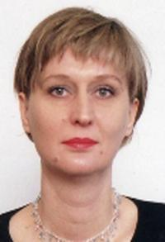 | Stojanka Mirceva is Associate Professor in Police and Human Rights at Faculty of Security – Skopje, University “St. Kliment Ohridski”- Bitola. Her professional background encompasses both, law enforcement and academic work. Prior to the academic career, her law enforcement engagement of 15 years involves various positions within the Ministry of Interior including operational and commanding level. She holds PhD in Law, Department of Law, “St. Cyril and Methodius” University, Skopje, Republic of Macedonia on dissertation topic, Police Response to the reported cases of Domestic Violence against Women; MA in International Criminology UK, Sheffield, University of Sheffield, Department of Law, Dissertation Topic, Investigation of Child Sexual Abuse: A Comparative Study of the legal frameworks in the Republic of Macedonia and England and Wales; BA in Criminology Faculty of Security, “St. Cyril and Methodius”, Skopje, Republic of Macedonia. She is author of numerous papers published in national and international journals.
Areas of expertise: Police organization, policing and police powers, vulnerable groups and non-discrimination, violence against women, victims in the criminal justice system, Child victims of sexual abuse, justice for children, restorative paradigm.

Rade Rajkovchevski (M) is Assistant Professor in the Faculty of Security in Skopje, University “St. Kliment Ohridski” – Bitola. Prior to his academic career which began in 2006, his work experience was associated to working in army, civil protection and security. He defended the Master’s thesis on national security policy and conflict prevention (2010) and his doctoral dissertation is related to the development and challenges of the European police cooperation (2013). He has references as researcher and expert in the EU-funded and several national projects. As most relevant are: COMPOSITE-Comparative Police Studies in the EU (FP7 Security, 2010-2014) and SAFFER-Shelters and Access for Empowerment and Risk Reduction (Contracted researcher for MARRI Regional Center, 2017). Also he has references as techical expert of the City of Skopje in two Europan Comission DG ECHO’s project dedicated to the civil protection and humanitarian assistance (ACHELOUS-Action of Contrast to Hydraulic Emergency in Local Urban Site [2014-2015] and EPICURO-European Partnership for Innovative Cities within an Urban Resilience Outlook [2017-2019]). He is author of two books, several book chapters and more than 30 articles dedicated to security issues. He is member of the Board of Trustee of “The Balkan Forum“ non-govermental initiative and revieiwer of the Routledge: Taylor and Francis Group’s journal (Policing and Society: An International Journal of Research and Policy) and other journals in Croatia, Poland, Columbia and other countries tackling with matter of policing, security and migrations. | 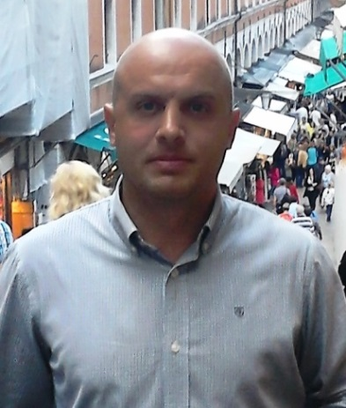
Areas of expertise: crisis management, civil protection, migrations, policing, and security policy.

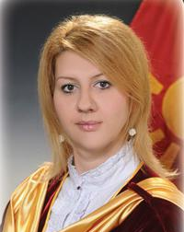 | Snezana Mojsoska is Associate Professor at Faculty of security on Principles of Economy, Money laundering (first and second cycle), Economy of Crime, Economic security. She has notable number of research papers dealing in money laundering, economic crime and economy. Since 2012 she is Vice Dean for finance on Faculty of security –Skopje. As researcher and national expert she was part of several project founded by Government of Republic of Macedonia, Booz Allen and Hamilton, USAID, project "Establishment of a probation system in RM" for the Ministry of Justice funded by the UK Embassy, Expert for Financial and pension system, for Project “Mandate for leadership”, economic researches on analysis of foreign trade data and preparation of publications intended for businessmen for USAID’s Business environment activity implemented by Booz Allen Hamilton and Ministry of economy and others. Also she is scientific reviewer in the country and abroad. During her development she have been on a lot of seminars, trainings: Funding and Budgeting of EU Projects – European Research Network, European Horizon 2020 Programme, Participant at CEPOL Course 2015/24, Money Laundering, Scuola di Perfezionamento per le Forze di Polizia, Rome (Italy), Changing in tax and law regulative, KPMG, webinars for Financial Crime Detection and others. She has published several papers which are indexed in ICI web of science, EBSCO, SCOPUS, Index Copernicus, and Elsevier.
Areas of expertise: economy, economic crime, money laudering, enterprunership, financial and tax issues.

Ljubica Pendaroska is independent Expert in Personal Data Protection and Privacy, and President of Cyber Security, Corporate Security and Crisis Management Initiative Macedonia. With more than 10 years of experience in personal data protection, within various EU projects, she is currently engaged as a Chairperson of the Ethical Committee of the Horizon2020 IECEU project and Key Personal data protection expert in the media project. Her education is related to International Law, Human rights Law and International relations. Ljubica recently served as Teaching assistant at the Faculty of Law and as Advisor to eminent Law firms, as well as Legal Counsel to the University of Information science & technology. She is member of Euro-Atlantic Council of Macedonia, Marshall Center Macedonia and Cyber Security Capital Network. Her believe is strongly related to lobbying and acting to raise public awareness and knowledge in privacy area.
Areas of expertise: Data protection, privacy, cyber security, EU/NATO integration

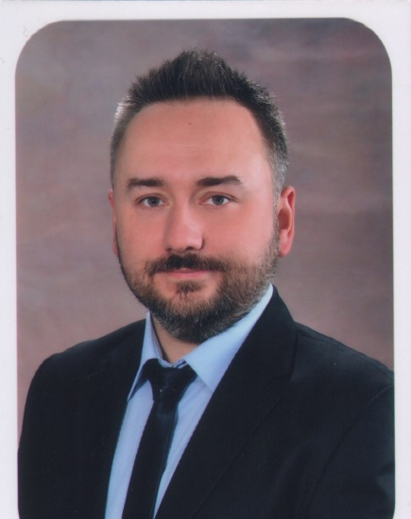 | Ivan Minčev is Assistant Professor in the Faculty of forestry in Skopje, University “St. Cyril and Methodius” in Skopje, dept. Land and Water. His academic work is consisted of working in the fields of erosion and torrent control, geographic Information systems, remote sensing and management of natural resources. He has extensive knowledge in GIS and spatial data management and more than 10 years of experience with GIS in several projects through local and international working teams, extensive knowledge in Remote Sensing: photointerpretation, semiautomatic pixel-based and object-based classification of imagery and further analyses. Master thesis: “Land cover mapping using object based classification of medium-high and high resolution imagery”. He is a co-author of one book and has published and presented several papers on international scientific conferences.
Areas of expertise: GIS, remote sensing, erosion and torrent control, environmental management and management of natural resources.

INTERNS:
Mrs. Elena Dimovska is BA in Criminalistics and Mphill in criminalistics studies at Faculty of Security- Skopje. Currently she is working as a Fellow at the Faculty of Security- Skopje, University "St. Kliment Ohridski"- Bitola. Her academic career began in 2013, few days before her graduation when she was declared as best student in her generation (2009-2013). First she was selected as a fellow on the subject Research Methodology of Security Sciences, but now she performs exercises on several subjects. At the moment she is working on her master thesis about qualitative research on security. She has participated in several projects and researches and she is co-author of 3 articles.
Areas of expertise: Security policy, qualitative research, human rights.

