Enjoy a different Localization Experience with Arrow Lingo, when you need to deliver your idea, message, business, to your audience in their native langue.

Once you decide this, make sure that your message will be perfectly delivered.

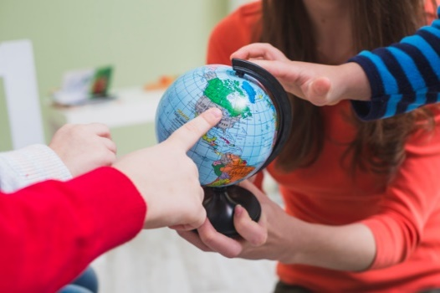
Here comes the need to an accurate provider for translation and localization solutions.

Arrow Lingo will transfer your ideas and messages to your target market in any country in the best image, increasing your opportunity to grow and expand.

In the following lines, we will present a brief of our services and rates

Translation & Linguistic | Transcription & Subtitling | Voice Over & Dubbing
Desktop Publishing | Localization Engineering | E-Learning Localization
Narration | LSO and Quality Checks | Adaptation
Trans-creation | Revision & M. T. P. E. | Copywriting

CAT Tools: SDL Trados, MemoQ, Mem-Source, GTT, Smart-Cat, and more…

DTP Applications:

Adobe Photoshop, Adobe InDesign, Adobe Illustrator, Adobe Frame Maker,

Adobe Flash, Adobe Robo Help, Adobe Dream viewer, Adobe Premier, Captivate

*Starting from as low as $ 2/page depending on complexity and direction.

Languages & Rates

Arrow Lingo covers a wide set of languages in different regions, using specialized, qualified and in-country translators. Our prices starts as shown in the following table:

Transcription, MTPE, Typing, and other offers will be set per project
Middle East & African |  | Asian Languages |  | European & Oceanic
Middle East | $/word | Asian-East | $/word | Oceanic | $/word
Arabic | 0.06 | Burmese | 0.14 | Fijian | 0.18
Dari | 0.09 | Ch. Simplified | 0.08 | Haitian-Creole | 0.12
Farsi | 0.08 | Ch. Traditional | 0.10 | Marshallese | 0.18
Hebrew | 0.15 | Hmong | 0.14 | European | $/word
Kurdish | 0.11 | Indonesian | 0.09 | Albanian | 0.10
Pashto | 0.08 | Japanese | 0.14 | Armenian | 0.09
Punjabi | 0.08 | Khmer | 0.14 | Azerbaijani | 0.09
Turkish | 0.08 | Korean | 0.12 | Danish | 0.14
Urdu | 0.08 | Lao | 0.14 | Dutch | 0.12
African | $/word | Malay | 0.12 | Finnish | 0.12
Afar | 0.10 | Tagalog | 0.11 | French | 0.09
Afrikaans | 0.10 | Thai | 0.09 | Georgian | 0.12
Amharic | 0.09 | Vietnamese | 0.09 | German | 0.12
Hausa | 0.10 | Asian - Indic | $/word | Greek | 0.09
Igbo | 0.10 | Assamese | 0.09 | Hungarian | 0.10
Kinyarwanda | 0.10 | Bengali | 0.08 | Italian | 0.09
Malagasy | 0.10 | Gujarati | 0.08 | Kazakh | 0.10
Somali | 0.09 | Hindi | 0.08 | Lithuanian | 0.10
Swahili | 0.09 | Kannada | 0.11 | Norwegian | 0.14
Tamazight | 0.09 | Karen | 0.11 | Polish | 0.09
Tigrinya | 0.09 | Malayalam | 0.08 | Portuguese | 0.09
Twi | 0.09 | Marathi | 0.08 | Romanian | 0.09
Wolof | 0.09 | Nepali | 0.08 | Russian | 0.09
Xhosa | 0.09 | Sinhalese | 0.08 | Spanish | 0.09
Yoruba | 0.09 | Tamil | 0.08 | Swedish | 0.14
Zulu | 0.09 | Telugu | 0.08

*For Editing, please add 40-50% of the above-mentioned cost
Fields & Subject Matters
Business & Economics | Life Sciences & Medical | IT & Telecoms (UI/UG)
Healthcare | Training & E – Learning | Environment
Documentation | Public Management/Finance | Economics
Legal & Governmental | Trade & Economic Consulting | Marketing & Advertising
Mining & Metal | Electronics | Engineering
Industrial Development | Video Games | Agriculture and Rural Development
Social Protection | Institutional | Infrastructure, Transport and Energy
Governance | Finance | Medical/Pharmaceutical/  Patents/Life Sciences
Human Development and Employment | Private Sector Development | Automotive
Telecommunications | Water and Irrigation | Software & Hardware
