Voice-over Agency and Subtitling Company
Adelphi Studio is a leading foreign language voice-over agency and subtitling company working with media companies in the UK, the USA, and worldwide. Our in-house dedicated audio visual translation department provide a quality subtitling and voice-over translation service.

Foreign Language Voice-overs
We have over 1,200 foreign language voice artists on our books in over 75 languages. Our voice-over services include Arabic voice-overs, Brazilian Portuguese voice-overs, French voice-overs, Chinese voice-overs, Russian voice-overs and more. With more voice samples to choose from than other agencies we have a great range of voice-over artists to suit any project. Unlike other companies we offer both high-end professional voice-over artists for large projects and great value in-house standard voices for budget productions. We have our own recording studios and a dedicated team of directors and sound engineers. Professional audio editing is standard for all of our voice-over projects.

Find out more about our voice-over services and choose your perfect voice artist.
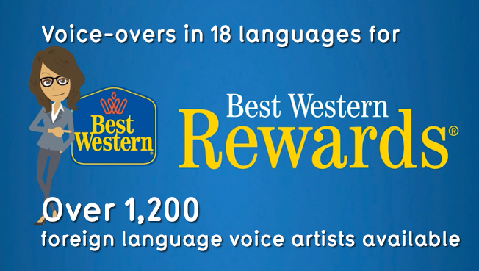

Accented English Voice Artists
We have over 120 foreign accented English voice artists available for you to choose from. Find the perfect voice for your project; no one else has a better selection. As with our foreign language voice artists our accented English voice artists are available on two different levels, professional and standard, in order to match any level of recording that you require.
Find your accented English voice artist now.
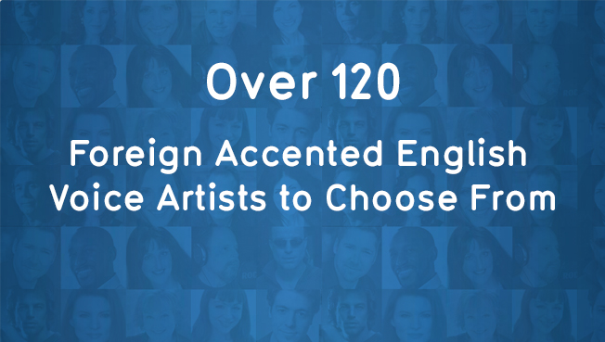

Voice-Over Translations and Transcriptions
As the media division of Adelphi Translations, an agency which has been providing translation services for clients all over the world for twenty years. Which means we can look after all your voice-over translations in-house, keeping everything under one roof. We also offer an audio transcription translation service, transcribing the audio, time-coding and then translating the text in any language. We also work in partnership with some of the biggest translation agencies in the world. We are happy to work with your translations and give advice on fonts for the more exotic languages.
Take a look at our audio translation and audio transcription pages to find out more.
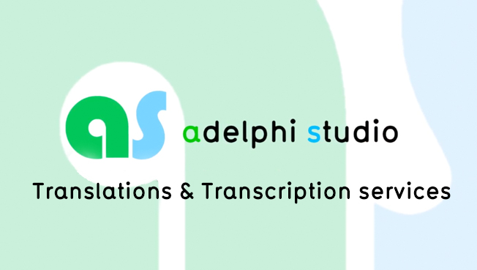

Subtitle Translation and Localisation
As a leading audio visual subtitling company our service includes the production of both open and closed caption subtitles in over 80 languages. We supply everything from the transcription of the original video, time-coding, translation of the transcribed text, SRT creation, through to the final subtitled video. Adelphi is a one-stop subtitling company that can cater for all your foreign language subtitling requirements, including subtitle translation direct from video.

See examples of our subtitling services in over 80 languages.
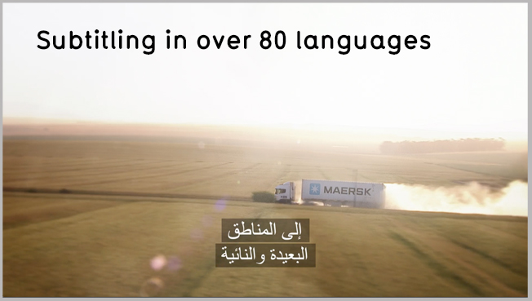

On-screen Text and Motion Graphics Localisation
We also localise any on-screen text, motion graphics and animations if required. Using industry standard software such as Adobe After Effects, our experienced team of studio animators and designers can localise your on-screen text, motion graphics or animations directly from the project files. We can localise into more than 100 languages and can advise on font usage and effects to be used. Our Articulate Storyline Localisation service localises not just the course text, but also the button and slider content too. If required we can add voice-overs and subtitles to resources in your course. We can localise Explainer videos in over 100 languages. Including translations, voice-overs, subtitling and on-screen text. We are able to translate the material directly via the original project files or provide files ready for incorporating into your production.
See on-screen text and motion graphics samples.
