CV
Of
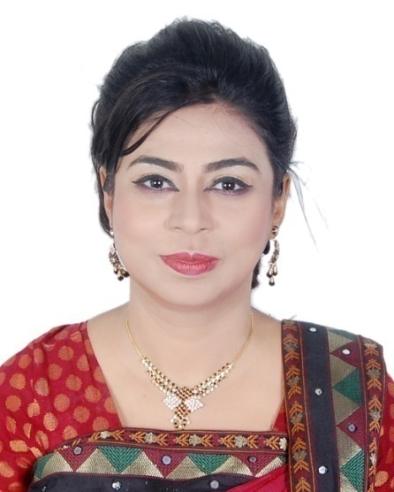

Kaspia Sultana
320/B West Dhanmondi,Road 8/A new,Old 15,Flat D/6
Phone: 01813556610
Teaching Experience:
Name of organization worked for | Designation | Duration
American International University Bangladesh | Assistant Professor (Department of English) | From May 22nd 2010 to 2021
ASA University Bangladesh | Assistant Professor (Department of English) | From February 17th , 2008 to  May 2010
Northern University Bangladesh | Assistant Professor (Department of English) | From 11th June 2005 to November 30th 2007

Experience as a Simultaneous Interpreter and Translator:
 | Name of the event  . | Venue | Languages of  Delivery | Date
ACF | Translation of manual of ACF titled as “ Baby Friendly Spaces: Holistic Approach for Pregnant, Lactating Women and their very young children in Emergency” |  |  | May 2017
CARE and UN Women | Translation of 3 C Basic Training Manual for RMG Workers 1st book and 2nd book for CARE, under supervision of UN Women. |  |  | September 2019
Nuclear Power Company, Russia | IN FACT SCIENCE FESTIVAL 2017  Dhaka, Bangladesh | Department of Mathematics  Dhaka University,  Auditorium of Bangladesh University of Engineetring Technology(BUET) | Bengali<>English  English <> Bengali | 25th – 28th September 2017
Bangladesh Export Processing Zone Authority(BEPZA) | “BEPZA Investors Summit 2018”: Simultaneous Interpretation of the speech of the Honorable Prime Minister of the Peoples’ Republic of Bangladesh with Simultaneous Interpretation System (SIS) | Bangabandhu International Convention Center | Bengali<>English | 24th January 2018
Organization of Islamic Conference(OIC) | “10th Session of the Islamic Conference of Tourism Ministers”:  Simultaneous Interpretation of the speech of the Honorable Prime Minister of the Peoples’ Republic of Bangladesh with Simultaneous Interpretation System (SIS) | Ballroom, Pan Pacific Sonargaon, Dhaka | Bengali<>English | 05th -06th February 2018
UNWomen | Simultaneous Interpretation of the program: “Identification and Introduction of Sustainable Approaches for Pre-Departure and Pre-Decision Trainings in Bangladesh” | CIRDAP Auditorium, Dhaka | Bengali<>English | 07th February 2018
UNWomen | Simultaneous Interpretation of the program: “ Dialogue on Gender Equality at Workplace : Success and Challenges of Career Advancement” with Simultaneous Interpretation System (SIS | Ballroom , The Westin Dhaka | Bengali<>English | 13th February 2018
Water Aid | Simultaneous Interpretation of the program: “Bangladesh Analysis on WASH Budget FY 2016 – 2017” with Simultaneous Interpretation System (SIS) | Bangladesh Reporters’ Unit y, Shegunbagicha, Dhaka | Bengali<>English | 13th May 2018
Water Aid | Simultaneous Interpretation of the program: “Introducing WASH Project Urban Poor Communities” with Simultaneous Interpretation System (SIS) | Pan Pacific Sonargaon Hotel, Dhaka | Bengali<>English | 10th June 2018
ACF | Written translation of ACF-INTERNATIONALMANUAL  Baby Friendly Spaces  Holistic Approach for Pregnant, Lactating Women and their very young children in Emergency (190 pages) | Dhaka Ahsania Mission,  CMILT office | English <> Bengali | May 2017
Dhaka Ahsania Mission (DAM | Written translation of DEVELOPMENT PROJECT PROFORMA/PROPOSAL (DPP)  Senior Citizen Home  Department of Social Services (DSS) | Dhaka Ahsania Mission, CMILT office | English <> Bengali | March 2018
Dhaka Ahsania Mission (DAM | Written translation of Development Project Proforma/Proposal (Dpp) For Establishment Of Ahsania Mission Children City For Comprehensive Rehabilitation Of Helpless, Poor And Distressed Children  Department of Social Services (DSS) | Dhaka Ahsania Mission,CMILT office | English <> Bengali | May 2018
US Aid, USFS, Ministry of Disaster Management,  Bangladesh Government | Simultaneous Interpretation of the program: “Bangladesh Incident Management System” with Simultaneous Interpretation System (SIS) | Amari Hotel,Dhaka | Bengali<>English  English <> Bengali | October 30th to November 4th
OXFAM | Simultaneous Interpretation of the program:  “Workshop on Community Resilience and Planning” | BRAC Learning Centre, Faridpur,Bangladesh | Bengali<>English  English <> Bengali | 27th to 29th November,2018
Translators Without Borders | Training the Interpreters involved in Humanitarian Services to the Rohingya people | White Orchid Hotel, CLC, CHIRD, Cox’s Bazar,Bangladesh | Bengali<>English  English <> Bengali | From 21st February 2019 to 31st March 2019
Ministry of Planning, Bangladesh Government , Bangladesh Bridge Authority,A2i,ED MAX | “NRB Engineers Convention 2019”:  Simultaneous Interpretation of the speech of the Honorable Prime Minister of the Peoples’ Republic of Bangladesh and other speeches of the program with Simultaneous Interpretation System (SIS) | Ballroom, Pan Pacific Sonargaon, Dhaka | Bengali<>English | 26th February 2019
US Aid,USFS,Ministry of Disaster Management,  Bangladesh Government | Simultaneous Interpretation of the program “Bangladesh Incident Management System” with Simultaneous Interpretation System (SIS) | Amari Hotel, Dhaka | Bengali<>English  English <> Bengali | April 22nd to 26th,2019
Omni Books | Written translation of Mokbula Monzur’s novel named Nagar Arannya | Work at home under supervision of Prof.Niaz Zaman,Dept.of English,DU | Bengali<>English | March 2003
Shwapnodal (Dream Team):Member Bangladesh Group Theatre Federation | Written translation of the Plays that are staged by the group | At different stations | Bengali<>English | April 2016 to March 2019
MYtv channel | English news presenter | English | Bengali<>English | 3rd June to 7th December 2016

Education and certifications

Masters in Development Studies( On going)

University of Dhaka

University of Dhaka, Institute of Modern Languages

M.A.ELT (English Language Teaching), 2003
Result: Second Class

University of Dhaka, Department of English

M.A. (English Linguistics) 1999
Result: Second Class

University of Dhaka, Department of English

Bachelor of Arts (English Literature), 1997
Result: Second Class

Holy Cross College, Dhaka
Higher Secondary Certificate, Humanities Group 1993
Result: First Division

Nahar Academy, Dhaka
Secondary School Certificate, Humanities Group 1991
Result: First Division

Personal Profile

Father : Md.Azizur Rahman

Mother : Setara Sultana

Present Address : 320/B West Dhanmondi, Road 8/A new, Old 15,Flat D/6

Permanent Address : 2/I block, H#1/A Ext Pallabi, Mirpur, Dhaka, Bangladesh

Cell : 01813556610

Date of Birth :31-12-75

Place of Birth :Dhaka

Nationality :Bangladeshi

Religion :Muslim

Marital Status :Married

Signature

