FATIMI Youssef
October 25th, 1987
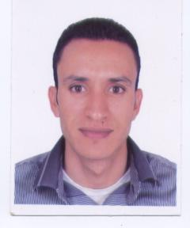
CHICHAOUA_ MOROCCO
GSM: 002 126 67 99 77 60
fatimiyoussef@yahoo.com

Education:
2011/2012: Professional Bachelor's Degree: “Teaching English as a Foreign Language” at Ecole Normale Supérieure, Rabat.
2010/2011: Fundamental Bachelor Degree “English Literature” at Cady Ayyad University, Marrakech.
2007/2008: Baccalaureate “Modern letters” at Al Imam Elboukhari High School, Chichaoua.
Experience:
2011/2012: One month teaching high school students under the supervision of Mrs. Khadija Bensghir at Abbi Baker Essiddiq High School, Rabat.
2011/2012: Participated in “Marrakech International ICT Conference” Organized by MATE, IATEFL & the British Council under the theme of “Opportunities, Challenges, and Practical Solutions for the Integration of ICT in Education” From 8 to 11 February, Marrakech.
2011/2012: Attended the workshop entitled, “Content and Language, Print and Digital” conducted by Lulu Campbell & sponsored by Macmillan Education. Rabat.
2011/2012: Participated in the 32-MATE national conference entitled, “Critical Thinking Skills in English Language Teaching” From 9 to 12 April, Oujda.
2011/2012: Attended the workshop entitled, “How to Get the Most from Your Course” conducted by Rob Metcalf & sponsored by Calliope. Rabat.
Languages:
Arabic (fluent)
English (fluent)
French (intermediate)
Computer Skills:
Microsoft Office Word 2007
Access to the Internet
Software Installation
Personal Interests:
Sport, travelling, reading, surfing in the Internet

