RESUME (CURRICULUM VITAE)
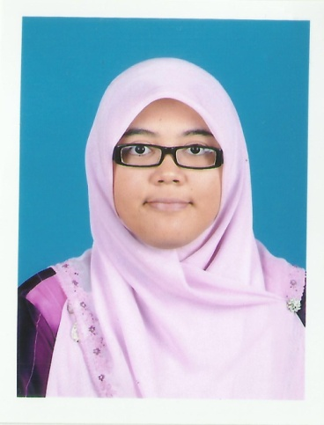
WAN NUR LIYANA BT WAN MUSTAFA

ADDRESS : 3007 LORONG SELAMAT, ALUR LINTANG, 22200 BESUT,
TERENGGANU
CONTACT NO. : 014-8329978
E-MAIL : wannurliyanawanmustafa@yahoo.com
PERSONAL PARTICULAR
DATE OF BIRTH : 14 APRIL 1988
PLACE OF BIRTH : TERENGGANU
AGE : 25 YEARS OLD
RACE / RELIGION : MALAY / ISLAM
MARITAL STATUS : SINGLE

CAREER OBJECTIVES
- TO GAIN KNOWLEDGE AND EXPERIENCE THROUGH WORKING
- TO BETTER FACILITATE STUDENTS LEARNING IN USING ENGLISH AS A SECOND LANGUAGE

EXPECTED SALARY
- RM 1500- RM 2000

EDUCATION BACKGROUND
- [2008-2013 ] - MANAGEMENT AND SCIENCE UNIVERSITY (MSU)
- BACHELOR IN EDUCATION (TESL)

- [2006-2008] - NEGERI SEMBILAN MATRICULATION COLLEGE
- CGPA : 2.91

- [2004-2005] - SEK.MEN.KEBTENGKU MAHMUD 2
- SIJIL PENILAIAN MENENGAH (SPM)
- SCIENCE STREAM
- 2A, 3B, 5C (ENGLISH- 1A)

TEACHING EXPERINCES

- TEACHING AS A PRACTICAL TEACHER AT SEK. MEN. KEB. SEKSYEN 7 FOR THREE MONTH (2012)
- TEACHING AS A PRACTICAL TEACHER AT SEK. MEN. KEB. BUKIT BESAR FOR THREE MONTH (2013)
- HAVE A LITTLE EXPERIENCE IN TRANSLATING A FEW DOCUMENTS FROM ENGLISH TO MALAY.

LANGUAGE PROFICIENCY
(Proficiency: 0 = Poor, 10 = Excellent)
LANGUAGE | SPOKEN | WRITTEN
ENGLISH | 10 | 10
MALAY | 10 | 10

IT SKILLS : MS Office (Word, Excel, Power Point, Publisher, Access)
SPECIAL CAPABILITIES
I am able to work under stress and I am also a hardworking person. I am a very patient to handle any problematic students in order to develop their knowledge. Besides, I am a very organize person, I always make plans before entering classes to attract their interest in learning. I also don’t mind to work with problematic students. In addition, I am willing to learn new things and gain experiences through it.

REFERENCES
DOC.NORHISHAM
(HEAD OF DEPARTMENT AND MENTOR)
FACULTY OF BUSINESS MANAGEMENT AND PROFESSIONAL STUDIES,
MANAGEMENT AND SCIENCE UNIVERSITY (MSU),
SHAH ALAM, SELANGOR.
012-4255212

MRS. SHAA’NORLIDA
(SUPERVISOR FROM SEK MEN KEB BUKIT BESAR)
SEK MEN KEB BUKIT BESAR (SMKBB), KUALA TERENGGANU,
013-9225090

