Curriculum Vitae

Valeria Mariel ACCINELLI

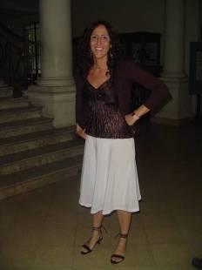

PERSONAL DETAILS

Place of Birth: La Plata / Buenos Aires / Argentina
Date of Birth: 09/11/79
Marital Status: married
Phone No (mobile): (0221)156255859
Email: vaccinelli@yahoo.com

EDUCATION

Universidad Nacional de La Plata. English Translator
Escuela de Educación Media Nº 12, M. B. Gonnet, La Plata. Secondary School Diploma
Universidad Nacional de La Plata, Italian course.
Plain Language Writing Workshop course by Joanna Richardson
SDL TRADOS course

WORK EXPERIENCE

Teleinterpreters/ Language Line, Over the Phone Interpreter. Duties: interpreting English into Spanish and Spanish into English in different areas such as Healthcare, Financial, Insurance and Legal.
Revista de Psicología de la Universidad Nacional de La Plata, Freelance Translator. Duties: translation of the article Reading comprehension in nacional and internacional programs of educational assessment
IBM, Technical Support for General Motors’ Dealers in the U.S.A.
TELEPERFORMANCE USA, Technical Support Agent for Vonage (VoIP Company). Duties: mainly offering technical support to customers in USA but also assisting customers in answering general and specific enquiries regarding the service.
COALA KIMBI (textile firm), Freelance Translator. Duties: translated company’s web page.
ANSUR ENGLISH INSTITUTE, Teacher. Duties: teacher of initial and intermediate courses.
ETON ENGLISH INSTITUTE, Teacher. Duties: replacement teacher on an intermediate course.

OTHER SKILLS

SDL TRADOS course
Knowledgeable computer user
Excellent communication skills
Ability to multi-task

REFERENCES

Available upon request.

