Curriculum Vitae

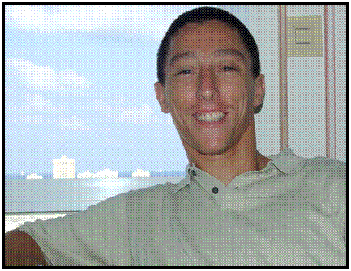

ROBERT Uriel GVIRZ
Rob25th@yahoo.com
Mobile Number: 09158862901

Employment History:

Account Manager/Data Analyst/Interpreter (Chinese Market), AKATEC Solutions - Playtech (Manila, Philippines)
Date: 2013

Head Instructor/Founder, Bujinkan China (Shanghai, China)
Date: 2011-2012

ESL Trainer, Fudan University Lower School (Shanghai, China)
Date: 2010-2011

Corporate Trainer, Roundtable Academy (Shanghai, China)
Date: 2009

Chinese Instructor, University of Haifa/Open University (Haifa, Israel)
Date: 2006–2008

Manager/Instructor, X-Park Extreme Sports Park (Haifa, Israel)
Date: 2005-2007

Dive Instructor, Dive Club (Eilat, Israel)
Date: 2004-2005

Education:

Fudan University (Shanghai, China)
Chinese Language Scholar
2009

Shanghai Foreign Language University (Shanghai, China)
Chinese Language Scholar
Date: 2008

Haifa University (Haifa, Israel)
Bachelor of Arts
Major in Asian Studies
Date: 2005-2008

Languages:

English (TEFL/TESOL Certified Instructor)
Hebrew (mother tongue level)
Russian (mother tongue level)
Chinese (high level)

Other Qualities:

Serious, responsible, and motivated
Quick self-learning ability
Good relations and communicative skills

Personal Interests:

Languages, Martial Arts, Diving, Surfing, Traveling, Cinema

Additional Information:

Date of Birth: November 14, 1980
Place of Birth: Haifa, Israel
Personal Status: Married

