Curriculum Vitae
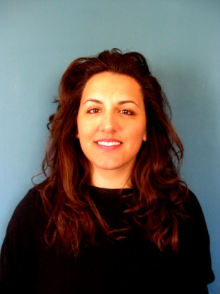

Personal Information
Name/Surname | Theodosia Koutroumanou
Date of Birth | 19 / 01 / 1978
Address | Voudouri 26-30, Piraeus, 18537
Mobile | +30 6978 552599
email | sara.koutroumanou@gmail.com

Education
10/2006-6/2007 | Subtitling Course  Glossologia, Athens
1996 – 2001 | B.A. in English Language and Literature  National and Kapodestrian University of Athens
9/2000-2/2001 | Student’s Exchange Program Erasmus –Free Movers  University of Luton, UK
1989-1995 High School Diploma,
Francohellenic School St.Paul
Seminars | Piraeus
10/2006-06/2007 | IT Skills Cambridge

Foreign Languages
English | Bachelor’s Degree and Cambridge Proficiency
Spanish | Superior
French | Sorbonne II

Professional Experience
10/2007-today  10/2001-6/2008 | Translator/Subtitlist/ Subtitle Editor  English to Greek, Spanish to Greek  Screen Art, AbFab Productions, The Cubicle  Teacher  Argoudelis-Poulopoulou Foreign Language Schools  The Scholars Group

Interests
Seminars | Arts, , shoemaking, travelling, kitesurfing, snowboarding

