Tayseer Mohamed Abdel Mongy 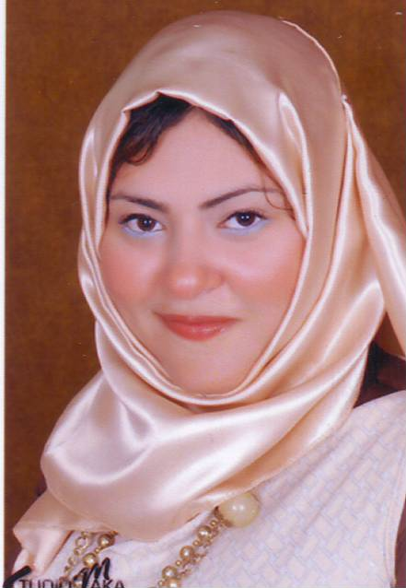
Address : Nasr City, Cairo.
Date of Birth : 30 January 1986
Home Number : (+2) 02 23891148
Mobile Number : (+2) 0100 5863640
Nationality : Egyptian
Marital Status : Married
E-mail Adress : tayseer.elmongy@gmail.com

- Objective : Seeking a challenging job and responsible position where my experience can be developed.

- Work Experience :
- (2008) Telemarketing at Arabic Industries Company.
- From August (2008) till (2010) TOUR OPERATOR (Spanish –
English) at Star Maker Travel Company.

- Courses :
- Spanish (Seven Levels at Cervantes Institute)
- English (Conversation Courses at MODLI The Ministry of Defense Language Institute )

- Education :
2004 - 2008 B.A. in “Spanish Language”, AL-Azhar University, Faculty
of Languages and Translation, Grade : Excellent.

- Personal Strengths :
    - Excellent Communication and Presentation.
    - Dependable, Persuasive and Enduring Character.
    - Self Motivated and Goal Oriented.
    - Ability to work well under pressure.
    - Ability to deal with all levels of management and personals.

- Special Skills :
- Languages Skills:
Mother Tongue : Arabic
Second Language : Spanish (Excellent spoken & written)
Third Language : English (Very Good spoken & written)

- Computer Skills:
Microsoft Office . photoshop
Internet Skills

REFERENCES FURNISHED UPON REQUEST

