Curriculum vitae | 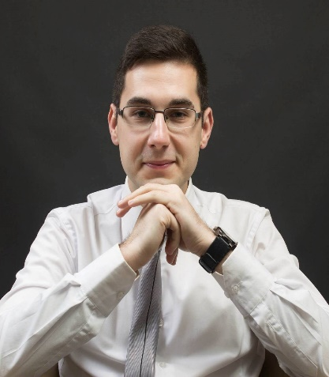
Personal data
Given name and family name | Strahinja Arsic
Address | Dundjerska 30/9, 18400 Prokuplje, Serbia
Phone numbers | 00 381 27 323 196 |  |  |  |  | Mobile phone: |  |  |  | 00 381 65 609 50 70
E-mail | strahinja90arsic@gmail.com
Citisenship | Serbian
Date of birth | 18.10.1990.
Sex | Male
Working experience
Dates | 07.07.2014.-07.02.2019.
Occupation / workplace | Online English teacher
Main jobs and responsibilities | Delivering online lessons of English to Japanese, Taiwaese, Korean and other countries’ students via Skype
The name of the company | BIBO Global Opportunity Inc.
Education
Dates | 01.10.2010.-01.07.2014. Basic academic studies of English language and literature, social and humanistic sciences (average grade: 9.00)  01.10.2014.-30.06.2015. Master academic studies of English language and literature; social and humanistic sciences (average grade: 9.67)
The name of received academic qualificatons | Bachelor of Arts (Linguistics) BA; Master of Arts (Linguistics) MA
The name and residence of the university/faculty | University of Pristina, Faculty of Philosophy, Kosovska Mitrovica, Serbia
Personal skills and competencies
Mother tongue | Serbian
Skills in other languages
 |  | Comprehension |  |  |  |  | Speaking |  |  |  |  | Writing
 |  | Listening |  | Reading |  |  | Spoken interaction |  | Spoken production
English language |  | C1 | Advanced | C1 | Advanced |  | C1 | Advanced | C1 |  | Advanced | C1 | Advanced
German language |  | B2 | Upper Intermediate  TELC B2 Certificate | B2 | Upper Intermediate  TELC B2 Certificate |  | B2 | Upper Intermediate  TELC B2 Certificate | B2 |  | Upper Intermediate  TELC B2 Certificate | B2 | Upper Intermediate  TELC B2 Certificate
French language |  | B1 | Intermediate | B1 | Intermediate |  | B1 | Intermediate | B1 |  | Intermediate | B1 | Intermediate
Greek language |  | B1 | Intermediate | B1 | Intermediate |  | B1 | Intermediate | B1 |  | Intermediate | B1 | Intermediate
Social skills and competencies | Friendly, respectful, well-organised, good listener, supportive, reliable and cooperative person
Organisational skills and competencies | Ability for team and individual work, the ability to plan and organize work and group activities through mutual agreement, good communication with employees and colleagues.  Great communication and cooperation skills, teamwork, organizational skills, organizing group work, good communication with employees and colleagues, working under pressure
Computer literacy | Microsoft Office (Word, Excel, Power Point); able to use internet generally
Additional information | Since 2012.-still : the youngest international table tennis umpire in Serbia and one of the youngest in the world  27.12. 2013. Received a prize awarded by the municipality of Prokuplje for special contribution in the domain of sport  Hobbies: playing table tennis, collecting football sticker albums, listening to music, watching movies, learning new languages.

