S.S.N SASTRY
M.A (Litt)., M. Com., DME..
822/1, 8th A Main, IV Block, BEL Layout, Vidyaranyapura, Bangalore – 560097, India
Ph: 91 80 2364 0739/. Mob: 91 98453 36344. Email: ssnsastry@gmail.com

About myself

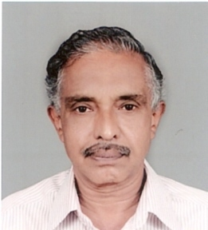

S S N SASTRY

I am taking up translation works and I provide translations from English to Telugu and Telugu to English and also from Kannada to English.

I have 30 years of experience in translation, proof reading and content development. I am dealing with various topics like arts, science, commerce, engineering, medical, environment, agriculture, culture and many others. I am thorough and abreast of latest developments in these fields

I am a senior journalist worked with Telugu and English dailies as Sub Editor, Senior Sub Editor and edition in-charge and Senior/ Chief Reporter. During all these years I have been a professional translator dealing with various subjects and have a good track record.

I am giving translations for many Ad agencies and corporate companies. I had translated many textbooks from English to Telugu as an assignment of Government of Karnataka and authored banking service books and general books into Telugu. Translated the contents of many CDs with Telugu Video content to English (for HP Chittoor, AP project and prepared content on various crops in Telugu). I have been translating and editing the Telugu works of Divine Park (spiritual museum at Saligrama near Mangalore) and in-charge of its Telugu magazine.

I am a regular translator for many Ad agencies for more than 30 years. I cater to the needs of my clients having offices in Delhi, Mumbai, Ahmedabad, Kolkata, US etc. besides many local clients.

I take the deadline seriously and provide the job on time.

I use MS Word for English and Baraha fonts for Telugu. I have computers, scanner, laptop, Internet, Fax and ISD line at home. I am available on mobile phone on 91 98453 36344

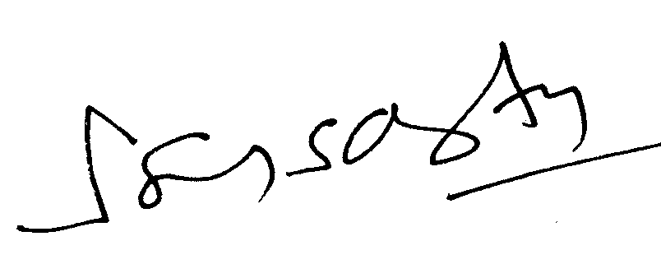

S.S.N. SASTRY

