RESUME

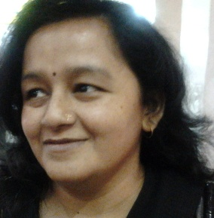
Seema Mishra

B.A (English)
C-301, Casa Imperia, Bhujbal vasti
Wakad, Pune, Maharashtra, India - 411057

Mobile +919503078436, +919158007067
E-mail: seemamshr70@gmail.com
Skype: seema.mishra.96742

Languages known to read & write: English (UK& US), Hindi, Marathi, Guajarati, Telugu

Experience:

1. Melademics Consultant Mumbai India – Freelance Writer/Translator, April 2004 to August 2007
2. Instablogs.com, Shimla, India – Freelancer writer, September 2007 to February 2008
3. Essaywriters.com, UK – Academic writer, Transcriptionist, Translator, Blog writer, February 2008 to December 2009
4. Mturk.com, US –Content writer, Transcriptionist, Translator, Blog writer, October 2009 to March 2011
5. Tangence.com, Noida, India – Content writer, February 2010 t0 April 2014
6. India parenting.com, Mumbai, India – Blog writer, Content writer, Press release, February 2010 and continued……
7. JM Techmind Pune, India –Web content writer, January 2017 and continued….

Nature of Job:

Being an online freelance writer, editor, Proof-reader, translator and transcriptionist my expertise is in:
- SEO article writing, Web content writing, writing blog posts, Grant writing, Review writing, Technical writing, Press release, Rewriting, Copy Writing
- Translation (Hindi < English, English < Hindi, English < English, Gujarati < English, Marathi < English, Telugu < English)
- Proofreading, Editing
- Transcription (Hindi < English, English < Hindi and English < English)
- Subtitling (Hindi < English, English < Hindi and English < English)
Published Articles:
http://ezinearticles.com/?The-Best-Secrets-of-Weight-Loss- Revealed&id=3550948
http://ezinearticles.com/?Obtain-Weight-Loss-With-Healthy-and-Nutritious- Weight-Loss-Tips&id=3620743
https://easyfitnessprograms.blogspot.in

Follow: - Facebook - seema.mishra.96742, Twitter - @seemamshr70, about me - seemamishra, LinkedIn – seema mishra

